Meets ASE Task: (A8-B-8) P-1 Diagnose emissions or drivability concerns without stored diagnostic trouble codes; determine needed action.
Name:_____________________________________
Date:_____________
Time on Task:_____________
Make/Model/Year:____________________________________
VIN:_________________________________
Evaluation (Enter number from 4, 3, 2, 1) :_________
Fuel Trim Diagnosis
Page 253
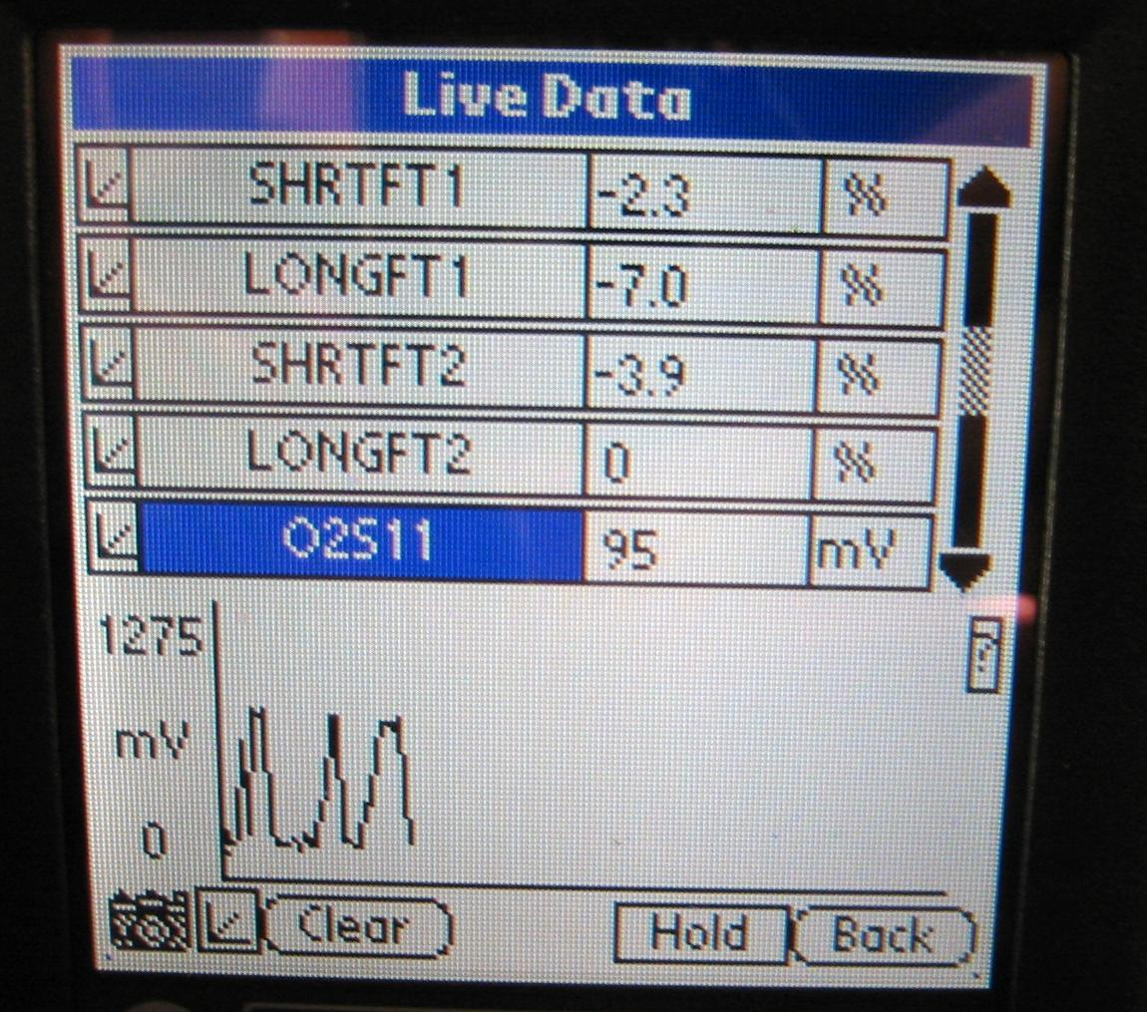
Fuel trim is the computer correction factor that uses the oxygen sensor to determine if more or less fuel needs to be delivered by the fuel injectors. Fuel trim is only available on a scan tool.

1. Connect a scan tool and select long-term
fuel trim (LTFT) (block learn) and short-
term fuel trim (STFT).

2. Start the engine and operate until normal
operating temperature and closed loop
status is achieved.

3. Record the following cell number and
LTFT amount:

LTFT STFT

Idle in Drive (if automatic transmission only) ________ ________

Idle in Park A/C off ________ ________

Idle in Park A/C on ________ ________

3000 RPM in Park ________ ________

Results: Fuel trim should be within plus or minus 10% or within 118-138 if the
block/integration is displayed as a binary number.

4. Based on the test results, what is the needed action? __________________________

________________________________________________________________

