Meets ASE Task: (A8-D-9) P-1 Inspect throttle body, air induction system, intake manifold and gaskets for vacuum leaks and/or unmetered air.
Name:_____________________________________
Date:_____________
Time on Task:_____________
Make/Model/Year:____________________________________
VIN:_________________________________
Evaluation (Enter number from 4, 3, 2, 1) :_________
Air Intake Inspection
Page 249
The idle air control is used to control idle speed by increasing or decreasing the amount of air entering the engine like what occurs when the accelerator pedal is depressed.

1. Inspect throttle body and related components for vacuum leaks.

OK NOT OK Describe faults: ____________________________
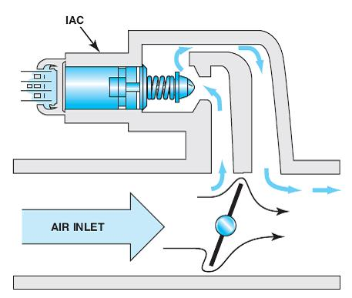
2. Connect a scan tool.

3. Look at the IAC commanded position
= ________ (should be 15 to 25% or counts
on a warm engine in park or neutral).

OK NOT OK

Diagnosis:

- IAC counts higher than normal. This could indicate one or more of the following:
1. Engine not fully warm
2. Some electrical load is on, such as daytime running lights or air
conditioning
3. Dirty throttle plates
4. Abnormal load on the engine
- IAC counts lower than normal. This could indicate one or more of the following:
1. A vacuum leak
2. Misadjusted idle speed control
3. Stuck or binding throttle cable or linkage

4. Based on the inspection of the system, what is the needed action? _______________

_______________________________________________________________

