Meets ASE Task: (A8-D-2) P-1 Replace fuel filter(s) where applicable.
Name:_____________________________________
Date:_____________
Time on Task:_____________
Make/Model/Year:____________________________________
VIN:_________________________________
Evaluation (Enter number from 4, 3, 2, 1) :_________
Fuel Filter Replacement
Page 248
1. Check service information for the recommended part number and fuel filter
replacement procedure.

a. Fuel filter part number = __________________

b. Recommended procedure: _________________________________________

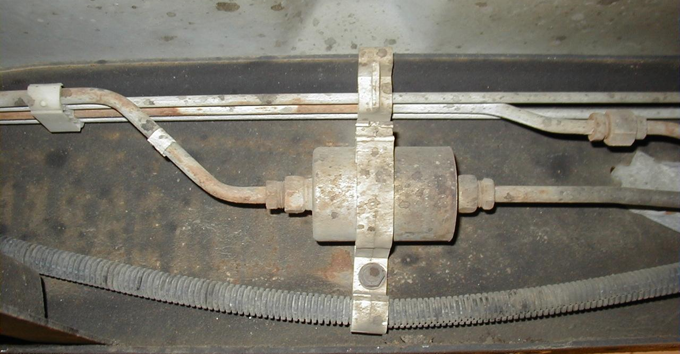
___________________________________________________________

2. Check all that apply:

Fuel system pressure should be relieved before removing the old filter

Special tools required to remove filter (describe): _____________________

____________________________________________________________

Direction of fuel flow labeled on the filter __________________________

Other (describe) _______________________________________________

____________________________________________________________

