Meets ASE Task: (A8-D-8) P-1 Inspect and test fuel pumps and pump control systems for pressure, regulation, and volume; determine needed action.
Name:_____________________________________
Date:_____________
Time on Task:_____________
Make/Model/Year:____________________________________
VIN:_________________________________
Evaluation (Enter number from 4, 3, 2, 1) :_________
Fuel Pump Current Draw Test
Page 247
1. Many electric fuel pumps can be measured for current draw in amperes. Higher
than normal amperage draw may indicate a clogged fuel filter causing back pressure
for the pump or a worn pump.
NOTE: Other makes and models of vehicles can be tested by connecting the ammeter in
series with the fuel pump fuse and then operating the engine. Check the wiring diagram for your specific vehicle.

2. Connect the digital multimeter, set to read amperes (A) and connect the red lead to the
positive (+) of the battery. Connect the black lead to the fuel pump test terminal. The
pump should run and an amperage reading should be observed on the meter. (Allow
the pump to run for 30 seconds.) Confirm the reading with acceptable specifications.
Reading = ________ amp

Normal readings: TBI = 2 to 5 amps (9-13 psi)
Port injection = 4 to 8 amps (35-45 psi)
Central port injection = 8 to 12 amps (55-64 psi)

- If the current is lower than specifications, check for:

- poor electrical connection at the fuel pump relay.
- poor connection at the fuel pump electrical connector.
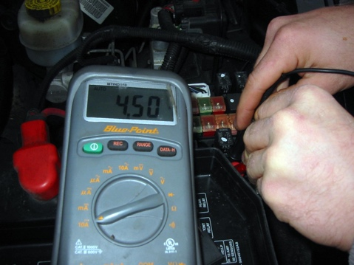
- poor ground connection.
- defective fuel pressure regulator

- If the current is higher than specifications, check for:

- clogged fuel filter.
- pinched fuel lines.
3. slowly rotating fuel pump.

3. Based on the test results, what is the needed action?

________________________________________________

________________________________________________

