Meets ASE Task: (A8-D-8) P-1 Inspect and test fuel pumps and pump control systems for pressure, regulation, and volume; determine needed action.
Name:_____________________________________
Date:_____________
Time on Task:_____________
Make/Model/Year:____________________________________
VIN:_________________________________
Evaluation (Enter number from 4, 3, 2, 1) :_________
Fuel Pump Testing
Page 246
1. Check service information and determine the factory specifications for acceptable fuel
pump pressure.

Fuel pump pressure specifications = ____________________________

2. Check service information, locate the fuel system pressure test valve or port, and
describe its location.

________________________________________________________________

3. Connect a fuel pressure gauge to the fuel pressure Schrader valve.

4. Start the engine and observe the fuel pressure.

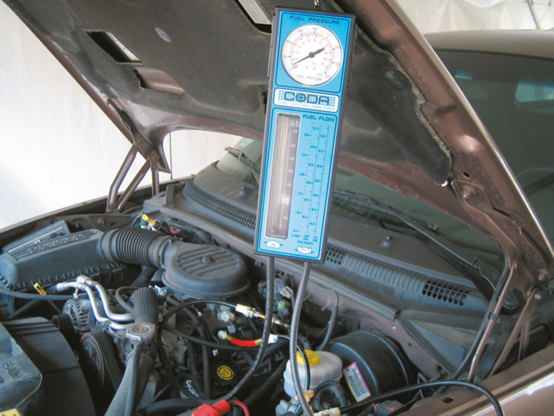
fuel pressure = _________________

OK NOT OK

5. Connect a hand-operated vacuum pump to the fuel
pressure regulator and apply 20 in. Hg. of vacuum.
Did the pressure decrease? __________

6. Check fuel pump volume (0.5 to 1.0 gallons per
minute).

7. Based on this test, what is the needed action?

________________________________________

________________________________________

