Meets ASE Task: (Not specified by ASE)
Name:_____________________________________
Date:_____________
Time on Task:_____________
Make/Model/Year:____________________________________
VIN:_________________________________
Evaluation (Enter number from 4, 3, 2, 1) :_________
Wide-Band Oxygen Sensor
Page 245
1. Wide-band oxygen sensors use four, five, or six wires. Check service information for
the color and identification of each of the wires used on the wide-band oxygen
sensors.

Wire Color Purpose Typical Voltage on Wire
During Closed-Loop
Operation
a. ____________ ___________________________ _____________
b. ____________ ___________________________ _____________
c. ____________ ___________________________ _____________
d. ____________ ___________________________ _____________
e. ____________ ___________________________ _____________
f. ____________ ___________________________ _____________
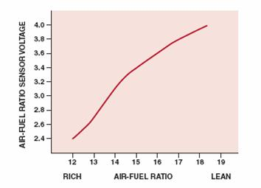
2. Check service information for the specified
testing procedure for diagnosing the wide-
band oxygen sensor.

_______________________________

_______________________________

Check all that are specified:

Scan tool
DMM
DSO
Other (describe) _________________________________________

3. Based on the results of the specified test procedure, what is the needed action?

__________________________________________________________________

__________________________________________________________________

