Meets ASE Task: (A8-B-5) P-1 Inspect and test computerized engine control system sensors, powertrain/engine control module (PCM/ECM), actuators, and circuits using a graphing multimeter (GMM), digital storage oscilloscope (DSO), and/or scan tool; determine needed action.
Name:_____________________________________
Date:_____________
Time on Task:_____________
Make/Model/Year:____________________________________
VIN:_________________________________
Evaluation (Enter number from 4, 3, 2, 1) :_________
Oxygen Sensor Diagnosis
Page 244
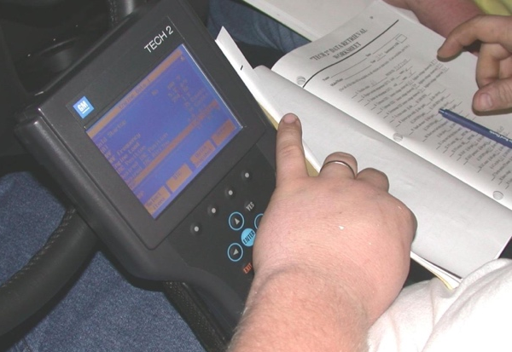
1. Connect the scan tool to the DLC and start the engine.

2. Operate the engine at a fast idle (2500 RPM) for
2 minutes to allow time for the oxygen sensor to
warm to operating temperature.

3. Observe the oxygen sensor activity on the scan tool
to verify closed loop operation.

4. Select “snapshot” mode and hold the engine speed steady and start recording.

5. Play back snapshot and place a mark beside each range of oxygen sensor voltage for
each frame of the snapshot.

Between 0 and 300 mV Between 300 and 600 mV Between 600 and 1000 mV

____________________ ______________________ _______________________
(record # of times) (record # of times) (record # of times)

6. Results: A good oxygen sensor and computer system should result in most snapshot
values at both ends (0 to 300 and 600 to 1000 mV). If most of the readings are in the
middle, the oxygen sensor is not working correctly.

OK NOT OK

7. Based on the test results, what is the needed action? ___________________________

_________________________________________________________________

