Meets ASE Task: (A8-B-5) P-1 Inspect and test computerized engine control system sensors, powertrain/engine control module (PCM/ECM), actuators, and circuits using a graphing multimeter (GMM), digital storage oscilloscope (DSO), and/or scan tool; determine needed action.
Name:_____________________________________
Date:_____________
Time on Task:_____________
Make/Model/Year:____________________________________
VIN:_________________________________
Evaluation (Enter number from 4, 3, 2, 1) :_________
MAF Sensor Diagnosis
Page 243
A "Mass Air Flow" sensor produces a variable output depending on the mass of the air flow through the sensor. A faulty MAF can cause drivability problems and stalling. A good MAF sensor should produce a signal that increases with engine speed.

1. Check service information for the specified procedure to follow to test the MAF
sensor.

__________________________________________________________________

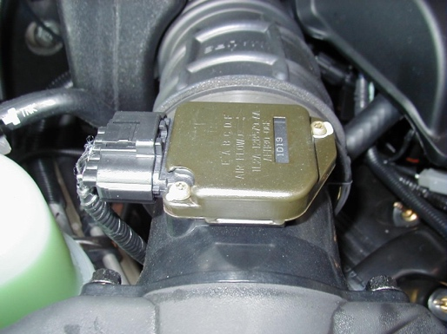
2. Use a meter or scope with a frequency counter to record
frequency or voltage at idle and at WOT (short bursts).

at idle = ____________ at WOT = _____________

3. Use a scan tool and record grams per second.

at idle = ____________ at WOT = _____________

A good MAF should read:

- greater than 100 grams per second (scan tool diagnosis)
- higher than 7000 Hertz (7 KHz) (digital MAF)
- higher than 4 volts (analog MAF)

4. If the MAF sensor reading does not exceed these values, the sensing wire may be
contaminated or the sensor itself is defective.

5. Based on the test results, what is the needed action? __________________________

_________________________________________________________________

_________________________________________________________________

