Meets ASE Task: (A8-B-5) P-1 Inspect and test computerized engine control system sensors, powertrain/engine control module (PCM/ECM), actuators, and circuits using a graphing multimeter (GMM), digital storage oscilloscope (DSO), and/or scan tool; determine needed action.
Name:_____________________________________
Date:_____________
Time on Task:_____________
Make/Model/Year:____________________________________
VIN:_________________________________
Evaluation (Enter number from 4, 3, 2, 1) :_________
MAP Sensor Diagnosis
Page 242
1. Check service information for the specified MAP sensor diagnosis procedure.
__________________________________________________________________

2. Perform a thorough visual inspection including:
a. Check the condition of vacuum hose (if equipped).
b. Check that the vacuum hose routing does not have any dips or sags in the
vacuum hose between the sensor and the intake manifold.

NOTE: A dip or low portion in the vacuum hose can create a trap where liquid fuel
(condensed gasoline fumes) or water (condensed steam) can accumulate and block the
vacuum signal to the MAP sensor.

c. Disconnect the vacuum hose (if equipped) from the MAP sensor. If anything,
such as a liquid or other substance comes out of the sensor or the hose, replace
the MAP sensor. Reconnect the vacuum hose to the MAP.

3. Turn the ignition key on (engine off), read and record the MAP sensor voltage (or
frequency) = _____ volts (Hz) (use either a scan tool or digital meter connected to the
signal wire). (Should be about 4.60 to 4.80 volts or 156-159 Hz.)

OK NOT OK

4. Start the engine and operate until normal operating temperature is achieved. Read and
record the MAP sensor voltage (or Hz) at idle speed = ________volts (Hz). (Should
be between 0.9 and 1.6 volts (102-109 Hz) if the engine varies between 17 and 21
inches of Hg.) OK NOT OK
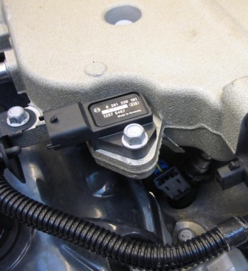
5 . Based on these tests, what is the needed action?

__________________________________________

__________________________________________

__________________________________________

