Meets ASE Task: (A8-B-5) P-1 Inspect and test computerized engine control system sensors, powertrain/engine control module (PCM/ECM), actuators, and circuits using a graphing multimeter (GMM), digital storage oscilloscope (DSO), and/or scan tool; determine needed action.
Name:_____________________________________
Date:_____________
Time on Task:_____________
Make/Model/Year:____________________________________
VIN:_________________________________
Evaluation (Enter number from 4, 3, 2, 1) :_________
Throttle Position Sensor Scope Test
Page 241
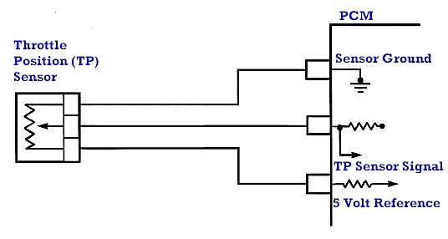
_____ 1. Check service information regarding the
location of the throttle position sensor
used on the vehicle being tested.

Location (describe):

_____________________________

_____ 2. Check service information for the wire colors used and their purpose
Wire 1 (color and purpose): _________________________
Wire 2 (color and purpose): _________________________
Wire 3 (color and purpose): _________________________

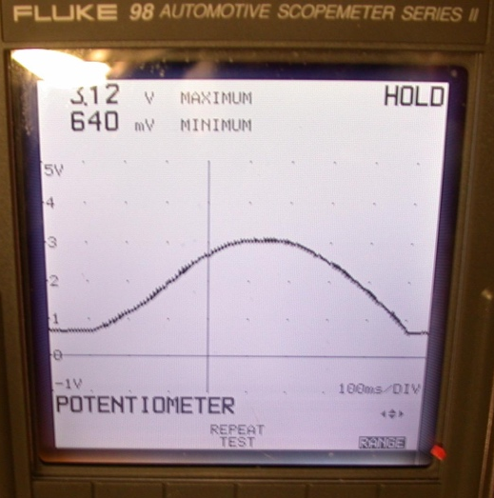
_____ 3. Measure the reference voltage (should be close to 5 volts) = ________.

_____ 4. Measure the sensor signal voltage at idle ____________,

specification = ___________________.

_____ 5. Measure the TP sensor at wide-open throttle (W.O.T.) =

___________________ volts
(should be about 4.5 volts).

_____ 6. Following the test equipment manufacturer’s instructions, show the instructor the waveform.
Instructor OK _______

_____ 7. Based on the comparison between the captured waveform and the specified waveform,
what action is needed? _____________________________________________________

____________________________________________________________________

