Meets ASE Task: (A8-B-5) P-1 Inspect and test computerized engine control system sensors, powertrain/engine control module (PCM/ECM), actuators, and circuits using a graphing multimeter (GMM), digital storage oscilloscope (DSO), and/or scan tool; determine needed action.
Name:_____________________________________
Date:_____________
Time on Task:_____________
Make/Model/Year:____________________________________
VIN:_________________________________
Evaluation (Enter number from 4, 3, 2, 1) :_________
Temperature Sensor Scan Tool Diagnosis
Page 240
1. Check service information for the recommended method for checking temperature
sensors using a scan tool.

__________________________________________________________________

__________________________________________________________________

2. List all the temperature sensors that are on the vehicle. Check all that apply.

ECT (describe location) ________________________________________

IAT (describe location) _________________________________________

TFT (describe location) _________________________________________

Other (describe) ______________________________________________
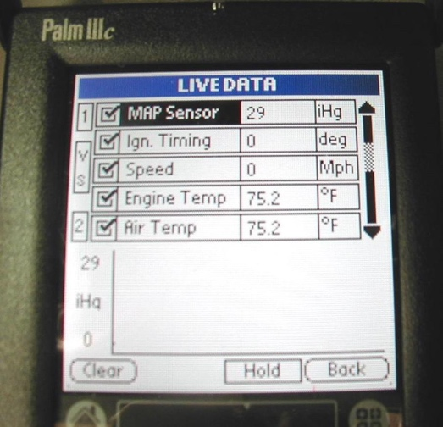
3. On a vehicle that has not been operated for several hours,
use a scan tool and list the temperature displayed for
various temperature sensors.

ECT = _______

IAT = ________

TFT = ________

Other (describe) = ____________________________

_____________________________________

4. Based on the test results, what is the needed action? ___________________________

__________________________________________________________________

