Meets ASE Task: (A8-B-3) P-1 Perform active tests of actuators using a scan tool; determine needed action.
Name:_____________________________________
Date:_____________
Time on Task:_____________
Make/Model/Year:____________________________________
VIN:_________________________________
Evaluation (Enter number from 4, 3, 2, 1) :_________
PCM Actuators Diagnosis
Page 239
1. Check service information for the specified method and procedures to follow to check
for proper operation of PCM-controlled actuators.
_________________________________________________________________
_________________________________________________________________
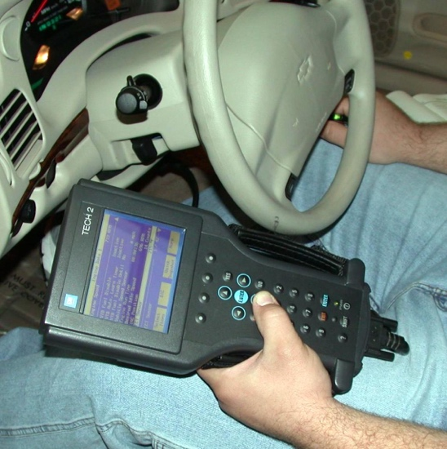
2. Check all that apply:

Use a factory scan tool.

Use a generic OBD-II scan tool.

Use a DMM to check for resistance
on communication circuits.

Use a fused jumper wire and a scan
tool to diagnose communication
errors.

Other (describe) ________________________________________________

3. List the actuators that can be tested.

a. _________________________ f. _________________________
b. _________________________ g. _________________________
c. _________________________ h. _________________________
d. _________________________ j. _________________________
e. _________________________ k. _________________________

4. Based on the test results, what is the needed action? _________________________

________________________________________________________________

