Meets ASE Task: (A8-C-5) P-2 Inspect, test, and/or replace ignition control module, powertrain/engine control module; reprogram/initialize as needed.
Name:_____________________________________
Date:_____________
Time on Task:_____________
Make/Model/Year:____________________________________
VIN:_________________________________
Evaluation (Enter number from 4, 3, 2, 1) :_________
Primary Ignition Inspection and Testing
Page 238
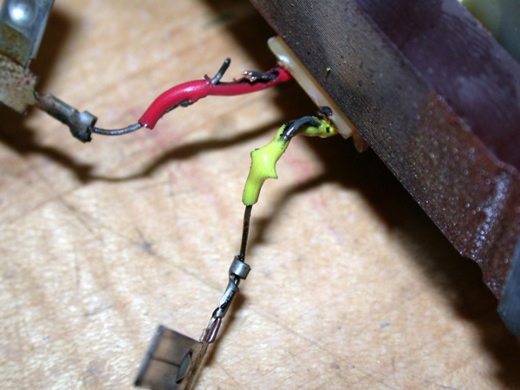
1. Check service information and determine what type of
ignition system is used on this vehicle?
Distributor ignition (DI)
Waste-spark (EI)
Coil-on-plug
Other (describe) _______________________

2. Check service information and determine what type of
primary circuit switching device is used on this system.
Pickup coil (pulse generator) Used on most
distributor-type ignition systems.
Hall-effect sensor
Magnetic sensor
Optical sensor
Other (describe) _______________________

3. Check service information and determine what color wires are used on the switching
device?
_______________, _______________, _______________, _______________
4. The primary ignition switching device signal goes to the:
Ignition control module (ICM)
Computer (PCM)
Other (describe) _____________________________________________

5. Using the service information, what are the steps to diagnosis a no-spark condition?
______________________________________________________
______________________________________________________
______________________________________________________

6. Could a fault in the primary ignition sensor cause a no-spark condition?
Yes No
7. Based on inspection and tests, what is the needed action? ______________________

