Meets ASE Task: (A8-C-4) P-1 Inspect and test crankshaft and camshaft position sensor(s); determine needed action.
Name:_____________________________________
Date:_____________
Time on Task:_____________
Make/Model/Year:____________________________________
VIN:_________________________________
Evaluation (Enter number from 4, 3, 2, 1) :_________
Position Sensor Waveform Testing
Page 237
1. Check service information regarding the location and type of position sensors used on
the vehicle being tested.
Crankshaft Position (CKP) Camshaft Position (CMP)
Location (describe): ______________________ ________________________

Type of sensor (Hall-Effect,
magnetic, etc.): ______________________ ________________________
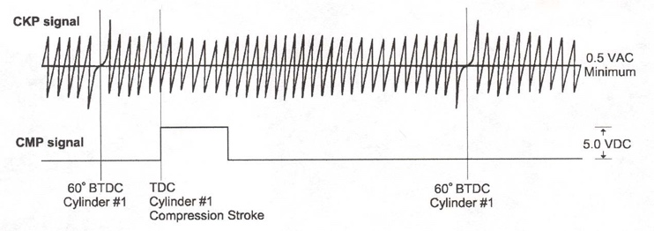

2. Check service information for the wire colors used and their purpose.
Crankshaft Position (CKP) Camshaft Position (CMP)
Wire 1 (color and purpose): ____________________ _______________________
Wire 2 (color and purpose): ____________________ _______________________
Wire 3 (color and purpose): ____________________ _______________________

3. Check service information for the specified voltage output and/or waveform for the
CKP and CMP sensors. CKP _____________________ CMP __________________

4. Following the test equipment manufacturer’s instructions, show the instructor the
waveforms. CKP – Instructor OK ____ CMP – Instructor OK ____

5. Based on the comparison between the captured waveform and the specified waveform,
what action is needed?
__________________________________________________________________

