Meets ASE Task: (A8-C-4) P-1 Inspect and test crankshaft and camshaft position sensor(s); determine needed action.
Name:_____________________________________
Date:_____________
Time on Task:_____________
Make/Model/Year:____________________________________
VIN:_________________________________
Evaluation (Enter number from 4, 3, 2, 1) :_________
Position Sensor Diagnosis
Page 236
1. Check service information for the type of sensor used for the crankshaft position
(CKP) and the camshaft position (CMP).

CKP – Describe the type of sensor _____________________________________
CMP – Describe the type of sensor _____________________________________
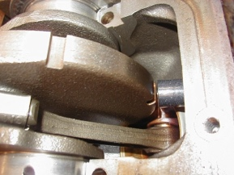
2. Check service information and determine the recommended testing
procedures for testing the CKP sensor.

Wire colors and their purpose:
Wire #1 ____________ _______________________________
Wire #2 ____________ _______________________________
Wire #3 ____________ _______________________________
Recommended testing procedure and specifications: _______________________
__________________________________________________________________
Test results: ________________________________ OK NOT OK
3. Check service information and determine the recommended testing procedures for
testing the CMP sensor.

Wire colors and their purpose:
Wire #1 ____________ _______________________________
Wire #2 ____________ _______________________________
Wire #3 ____________ _______________________________
Recommended testing procedure and specifications: _______________________
__________________________________________________________________
Test results: ________________________________ OK NOT OK
4. Based on the test results, what is the needed action? __________________________

