Meets ASE Task: (A8-C-2) P-1 Remove and replace spark plugs; inspect secondary ignition components for wear and damage; determine needed action.
Name:_____________________________________
Date:_____________
Time on Task:_____________
Make/Model/Year:____________________________________
VIN:_________________________________
Evaluation (Enter number from 4, 3, 2, 1) :_________
Ignition Coil Testing
Page 235
1. Check service information for the specified ignition coil testing procedure.

_________________________________________________________________

2. Visually inspect the coil(s) for carbon track and other faults. OK NOT OK
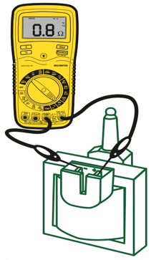
3. Check the primary winding resistance.

Specification: ______________________

Actual: ___________________________

OK NOT OK

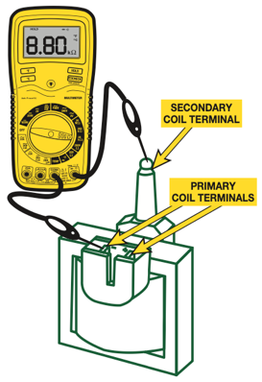
4. Check the secondary winding resistance.

Specification: ______________________

Actual: ___________________________

OK NOT OK

6. Based on the inspection and tests, what is the needed action? ___________________

_________________________________________________________________

