Meets ASE Task: (A8-C-2) P-1 Remove and replace spark plugs; inspect secondary ignition components for wear and damage; determine needed action.
Name:_____________________________________
Date:_____________
Time on Task:_____________
Make/Model/Year:____________________________________
VIN:_________________________________
Evaluation (Enter number from 4, 3, 2, 1) :_________
Spark Plugs Inspection
Page 234
1. Check service information and determine the correct plug code and gap for your
vehicle using a spark plug application guide.

Engine: # Cylinders_____ VIN# ____________________
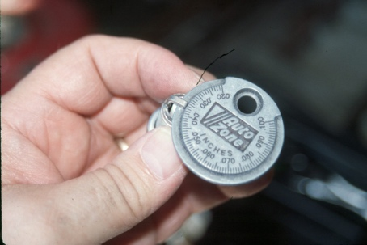
Brand __________ Code # __________ Gap __________

2. Remove and label all the spark plug wires.

3. Determine the condition and gap of all spark plugs:

Condition Gap
1. ______________________________________ _______
2. ______________________________________ _______
3. ______________________________________ _______
4. ______________________________________ _______
5. ______________________________________ _______
6. ______________________________________ _______
7. ______________________________________ _______
8. ______________________________________ _______

4. Reinstall the spark plug (start by hand).

5. Use a torque wrench and torque the spark plugs to the proper torque.

Specified torque = ______________

6. Start the engine. Check for possible rough running caused by crossed or loose spark
plug wires.

OK NOT OK

7. Based on the inspection of the spark plugs, what is the needed action? ____________

__________________________________________________________________

