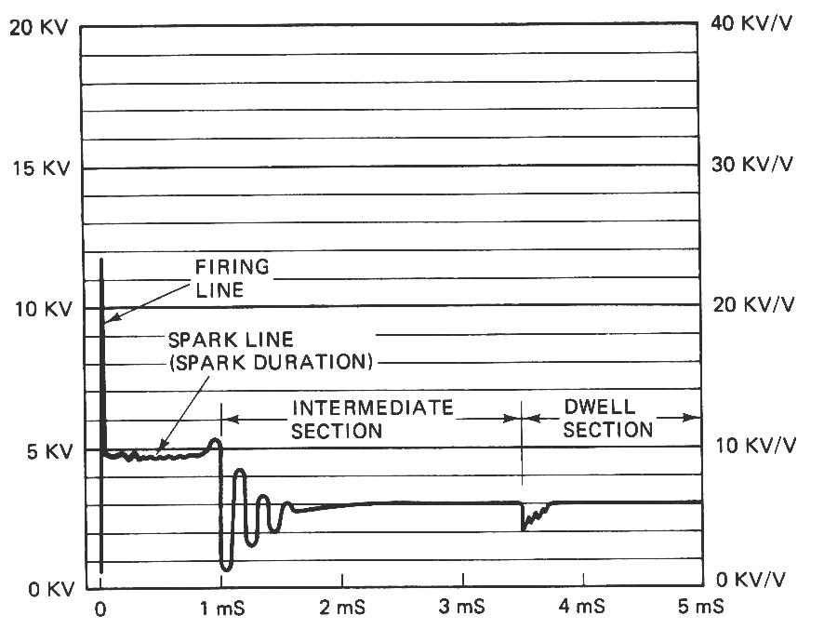
Meets ASE Task: (Not specified by ASE)
Name:_____________________________________
Date:_____________
Time on Task:_____________
Make/Model/Year:____________________________________
VIN:_________________________________
Evaluation (Enter number from 4, 3, 2, 1) :_________
Ignition Scope Analysis
Page 233
1. Check service information regarding the
specified method for attaching and using
a secondary circuit oscilloscope.
_______________________________
_______________________________

2. Type of ignition:
Distributor
Waste spark
Coil-on-plug

3. Connect the ignition scope to the system as per the scope manufacturer’s
instructions.

4. Brand of scope used: ________________________________________

5. Describe the hookup procedure. ___________________________________________

6. Start the engine and observe the secondary ignition waveform.

Firing Voltage (KV) Spark Line Length (ms)
(voltage should be 5-15 KV) (length should be 1-2 ms)

Cylinder #1 _______________________ _____________________
Cylinder #2 _______________________ _____________________
Cylinder #3 _______________________ _____________________
Cylinder #4 _______________________ _____________________
Cylinder #5 _______________________ _____________________
Cylinder #6 _______________________ _____________________
Cylinder #7 _______________________ _____________________
Cylinder #8 _______________________ _____________________

7. Based on the test results, what is the needed action? _________________________

