Meets ASE Task: (A8-B-5) P-1 Inspect and test computerized engine control system sensors, powertrain/engine control module (PCM/ECM), actuators, and circuits using a graphing multimeter (GMM), digital storage oscilloscope (DSO), and/or scan tool; determine needed action.
Name:_____________________________________
Date:_____________
Time on Task:_____________
Make/Model/Year:____________________________________
VIN:_________________________________
Evaluation (Enter number from 4, 3, 2, 1) :_________
Scan Tool Testing of the Ignition System
Page 232
1. Check service information for the recommended procedures to follow when using a
scan tool to monitor what the vehicle computer is looking at and what commands are
being sent to the various engine actuators and components.
2. Connect the scan tool to the data link connector (DLC) of the vehicle and scroll
through the various parameters until engine RPM and ignition spark timing can
be viewed.
Idle RPM = _____ Spark advance at idle = _____
3. Slowly increase engine speed and observe the amount of spark advance.
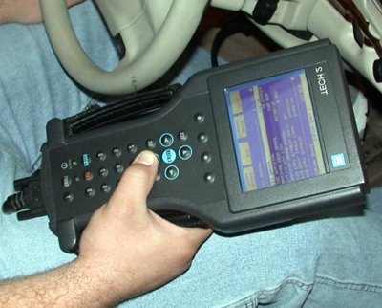
Spark advance at 1000 RPM = _______ degrees
Spark advance at 1500 RPM = _______ degrees
Spark advance at 2000 RPM = _______ degrees
Spark advance at 2500 RPM = _______ degrees
4. Scroll the display of the scan tool until knock sensor (KS) activity or timing retard is displayed (if the vehicle is so equipped).
KS signal at idle = _______ (should be zero) (The engine should not have detected an engine knock.)
5. Increase engine speed while observing KS or timing retard amount. Did the computer
retard timing?
Yes No
6. Lightly tap on the engine block and observe KS or timing retard with the engine
warmed above idle speed. Was a knock detected?
Yes No
7. Based on the test results, what is the needed action? ___________________________

