Meets ASE Task: (A8-C-3) P-1 Diagnose ignition system related problems such as no-starting, hard starting, engine misfire, poor driveability, spark knock, power loss, poor mileage, and emissions concerns; determine needed action.
Name:_____________________________________
Date:_____________
Time on Task:_____________
Make/Model/Year:____________________________________
VIN:_________________________________
Evaluation (Enter number from 4, 3, 2, 1) :_________
Electronic Ignition Diagnosis
Page 231
1. Check service information for the specified diagnostic procedures to follow when
troubleshooting the ignition system.
__________________________________________________________________
__________________________________________________________________
__________________________________________________________________
2. Most test procedures specify that the spark be tested using a spark tester. Use a spark
tester and determine that a spark does occur at each cylinder.
Cylinder #1 OK NOT OK (describe) ________________
Cylinder #2 OK NOT OK (describe) ________________
Cylinder #3 OK NOT OK (describe) ________________
Cylinder #4 OK NOT OK (describe) ________________
Cylinder #5 OK NOT OK (describe) ________________
Cylinder #6 OK NOT OK (describe) ________________
Cylinder #7 OK NOT OK (describe) ________________
Cylinder #8 OK NOT OK (describe) ________________

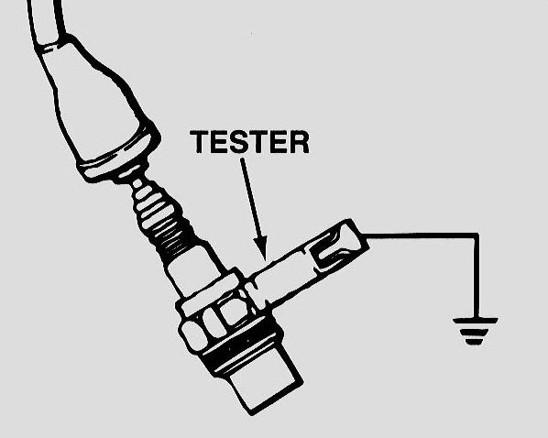
3. Based on the test results, what is the needed
action?
__________________________________
__________________________________
__________________________________
__________________________________

