Meets ASE Task: (A8-C-1) P-1 Identify ignition system components and configurations.
Name:_____________________________________
Date:_____________
Time on Task:_____________
Make/Model/Year:____________________________________
VIN:_________________________________
Evaluation (Enter number from 4, 3, 2, 1) :_________
Ignition System Identification
Page 229
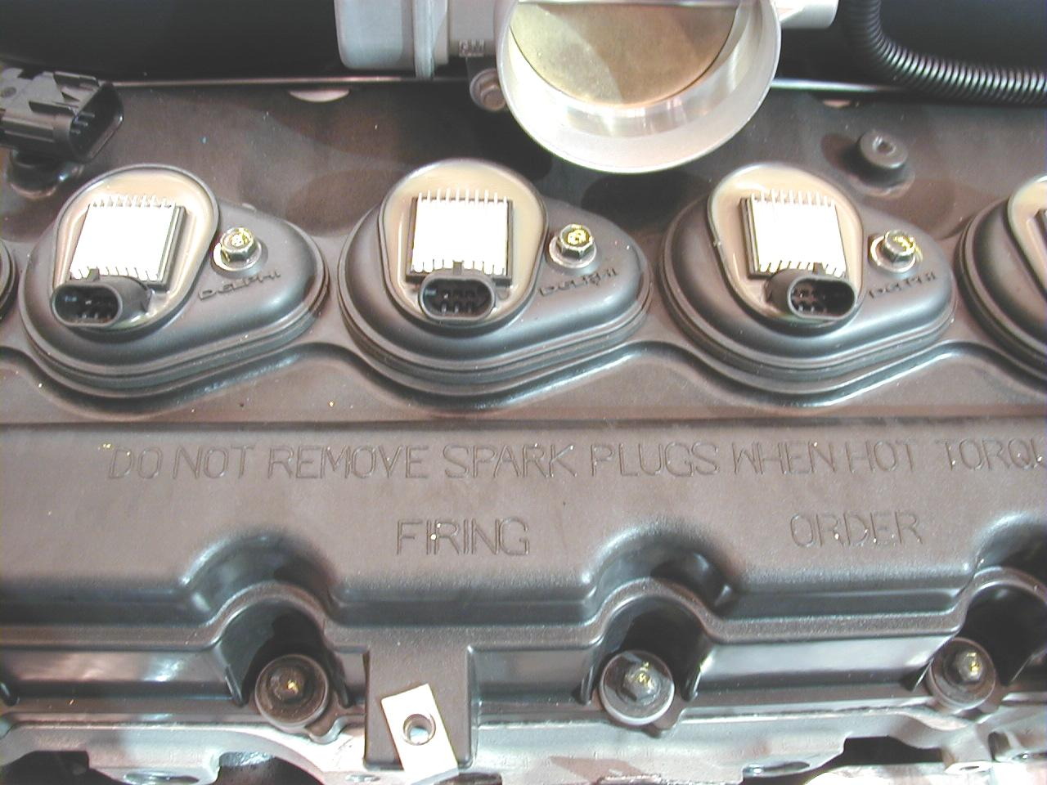
1. Check service information and
determine what type of
ignition system is used on this
vehicle?
Distributor ignition (DI)
Waste-spark (EI)
Coil-on-plug
Other (describe)
_________________________
_________________________

2. Check service information and determine what type of primary circuit switching
device is used on this system.
Pickup coil (pulse generator) Used on most distributor-type ignition
systems.
Hall-effect sensor
Magnetic sensor
Optical sensor
Other (describe) ____________________________________________

3. What color wires are used on the switching device?
_______________, _______________, _______________, _______________
4. Using service information, determine where the primary ignition switching device
signal goes:
Ignition control module (ICM)
Computer (PCM)
Other (describe) _____________________________________________

