Meets ASE Task: (Task not specified by ASE)
Name:_____________________________________
Date:_____________
Time on Task:_____________
Make/Model/Year:____________________________________
VIN:_________________________________
Evaluation (Enter number from 4, 3, 2, 1) :_________
Biodiesel Fuel
Page 228
1. Check service information to determine what percentage of biodiesel is recommended
for use. Check all that apply:
Biodiesel not recommended
B5 (state any restrictions) _____________________________________
B20 (state any restrictions) ____________________________________
Other (describe) _____________________________________________

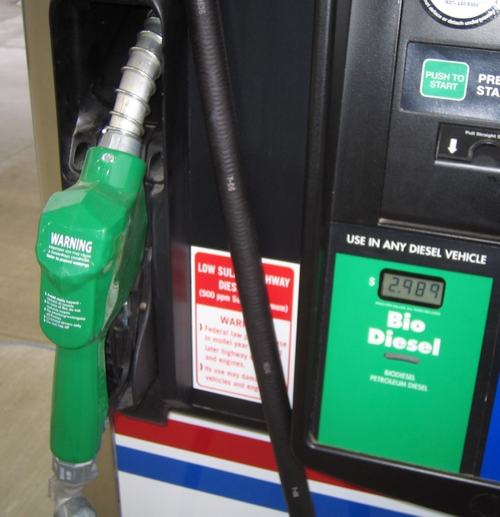
2. List places where biodiesel can be purchased in your area.
__________________________________
__________________________________
__________________________________
__________________________________

3. What is the cost difference between biodiesel
and regular diesel fuel?
__________________________________
__________________________________
__________________________________
__________________________________

