Meets ASE Task: (A8-D-7) P-1 Check fuel for quality, composition, and contamination; determine needed action.
Name:_____________________________________
Date:_____________
Time on Task:_____________
Make/Model/Year:____________________________________
VIN:_________________________________
Evaluation (Enter number from 4, 3, 2, 1) :_________
Alcohol Content in Gasoline
Page 225
Take the following steps when testing gasoline for alcohol content.
1. Pour suspect gasoline into a small clean beaker or glass container.
DO NOT SMOKE OR RUN THE TEST AROUND SOURCES OF IGNITION!

2. Carefully fill the graduated cylinder to the 10-mL mark.

3. Add 2 mL of water to the graduated cylinder by counting the number of drops from an
eyedropper. (Before performing the test, the eyedropper must be calibrated to
determine how many drops equal 2.0 mL.)

4. Put the stopper in the cylinder and shake vigorously for 1 minute. Relieve built-up
pressure by occasionally removing the stopper. Alcohol dissolves in water and will
drop to the bottom of the cylinder.

5. Place the cylinder on a flat surface and let it stand for 2 minutes.

6. Take a reading near the bottom of the cylinder at the boundary between the two
liquids.

7. For percent of alcohol in gasoline, subtract 2 from the reading and multiply by 10.
For example: The reading is 3.1 mL: 3.1 - 2 = 1.1 X 10 = 11% alcohol
The reading is 2.0 mL: 2 - 2 = 0 X 10 = 0% alcohol (no alcohol)
If the increase in volume is 0.2% or less, it may be assumed that the test gasoline
contains no alcohol. Alcohol content can also be checked using an electronic tester.
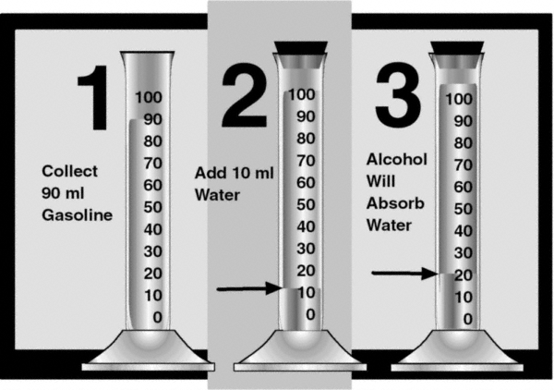
8. Based on the test results, what action is
needed? ____________________________
________________________________
________________________________
________________________________
________________________________

