Meets ASE Task: (A8-A-2) P-1 Retrieve and record DTCs, OBD monitor status, and freeze frame data; clear codes and data when directed.
Name:_____________________________________
Date:_____________
Time on Task:_____________
Make/Model/Year:____________________________________
VIN:_________________________________
Evaluation (Enter number from 4, 3, 2, 1) :_________
Fuel-Related Scan Data
Page 224
1. Check service information for the specified octane rating and/or alcohol type to be
used.
Recommended octane of gasoline = _________________________
Recommended alcohol type and percentage (if equipped for alcohol or flexible
fuel use) = ________________________ ___________
2. Connect a scan tool to the data link connector and check for fuel-related data. Check
all that apply.
NOTE: Use the vehicle specific or enhanced version to get the most information from the vehicle.
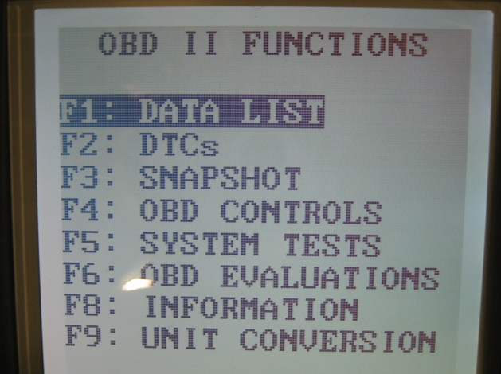
________ Calculated octane
________ Gallons of fuel remaining
________ Percentage of alcohol in the
fuel (flexible fuel vehicle)
________ Fuel pressure
________ Fuel temperature
________ Other (list and/or describe) __________________________________

3. Based on the results of the information obtained and the specification for the vehicle,
what is the interpretation of the data?
__________________________________________________________________
__________________________________________________________________

