Meets ASE Task: (A7-D-1) P-1 Inspect HVAC system heater ducts, doors, hoses, cabin filters, and outlets; determine needed action.
Name:_____________________________________
Date:_____________
Time on Task:_____________
Make/Model/Year:____________________________________
VIN:_________________________________
Evaluation (Enter number from 4, 3, 2, 1) :_________
Inspect HVAC System Ducts and Cabin Filter
Page 223
1. Check service information for specified procedure to follow when inspecting HVAC
ducts, doors, and vents. Describe the specified procedure. _______________________
___________________________________________________________________
___________________________________________________________________
2. Check service information for how to access and locate the cabin filter.
Describe the location of the cabin filter ___________________________________
___________________________________________________________________
Describe the procedure required to access the cabin filter. ____________________ ____________________________________________________________________
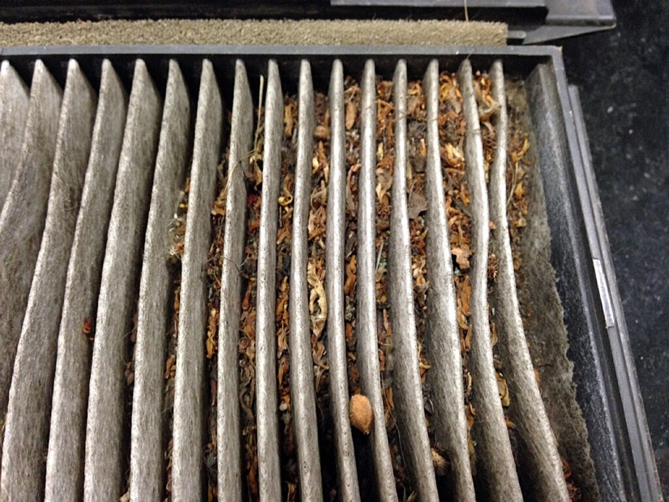

3. Describe the needed action. ______________________________________________
_________________________________________________________________

