1. Experiment: Can water be made to boil in a paper cup? Explain why or why not.
Evaluation (Enter number from 4, 3, 2, 1) :_________

Meets ASE Task: (A0-F-11) Uses scientific, technical, engineering and mathematics (STEM) principles and reasoning to accomplish assigned tasks.
Water Boil Experiment

Name:_____________________________________
Date:_____________
Time on Task:_____________
Make/Model/Year:____________________________________
VIN:_________________________________
Page 22
__________________________________________________________________
__________________________________________________________________
__________________________________________________________________
2. Place water in a paper cup half full of water, place it on a grill for support, and place a
thermometer in the water.
3. Use a propane torch to heat the bottom of the cup. Will the paper cup burn? Explain
why or why not? _______________________________________________________
__________________________________________________________________
4. Was the heat from the torch able to boil the water? _________________________
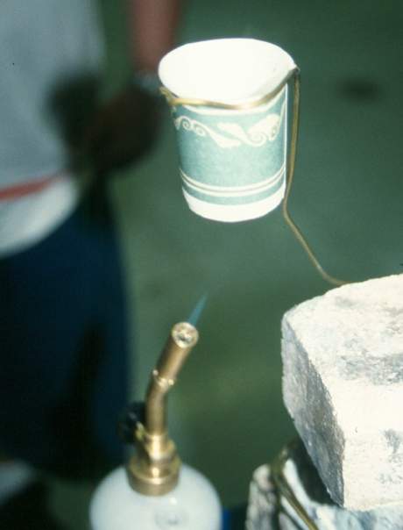
5. Explain why it took a long time to boil after reaching 212°F. _____________________________________________________

