Meets ASE Task: (A7-E-1) P-1 Demonstrate awareness of the need to recover, recycle, and handle refrigerants using proper equipment and procedures.

Name:_____________________________________
Date:_____________
Time on Task:_____________
Make/Model/Year:____________________________________
VIN:_________________________________
Evaluation (Enter number from 4, 3, 2, 1) :_________
Refrigerant Handling Equipment
Page 219
1. What brand and type of refrigerant handling equipment is being used (describe)?
____________________________________________________________________
____________________________________________________________________
____________________________________________________________________
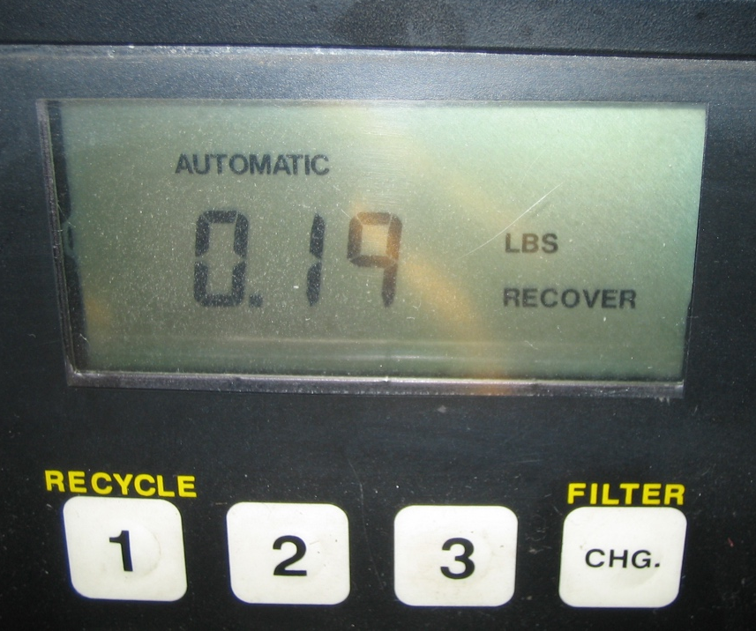

2. Check the instructions for the equipment and list the maintenance items that should be
performed. ______________________________________________________________
____________________________________________________________________
____________________________________________________________________
3. Check the instructions and describe how to properly use the refrigerant handling
equipment. _____________________________________________________________
____________________________________________________________________
___________________________________________________________________

