Meets ASE Task: (A7-C-1) P-1 Inspect engine cooling and heater systems hoses and pipes; determine needed action.
Name:_____________________________________
Date:_____________
Time on Task:_____________
Make/Model/Year:____________________________________
VIN:_________________________________
Evaluation (Enter number from 4, 3, 2, 1) :_________
Inspect Belts and Hoses
Page 218
1. Check service information for the procedures and specifications for determining the
condition of belts and hoses. _______________________________________________
____________________________________________________________________
____________________________________________________________________
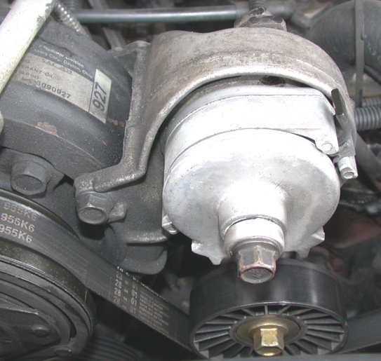
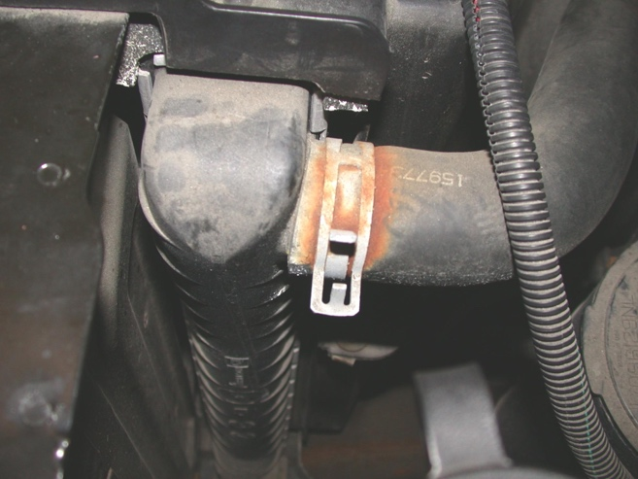

2. Describe the condition of the heater hoses. ____________________________________
___________________________________________________________________
3. Describe the condition of the radiator hoses. ___________________________________
___________________________________________________________________
4. Describe the condition of the drive belt(s). ____________________________________
___________________________________________________________________
5. Based on the inspection results, what is the needed action? ________________________
____________________________________________________________________
____________________________________________________________________

