Meets ASE Task: (A7-B-11) P-2 Remove, inspect, reinstall and/or replace condenser; determine required oil type and quantity.

Name:_____________________________________
Date:_____________
Time on Task:_____________
Make/Model/Year:____________________________________
VIN:_________________________________
Evaluation (Enter number from 4, 3, 2, 1) :_________
Condenser Replacement
Page 217
1. Check service information and determine the specified procedures to follow to replace
the condenser. (list the procedures)
a. _______________ d. _______________ g. _______________
b. _______________ e. _______________ h. _______________
c. _______________ f. _______________ i. _______________
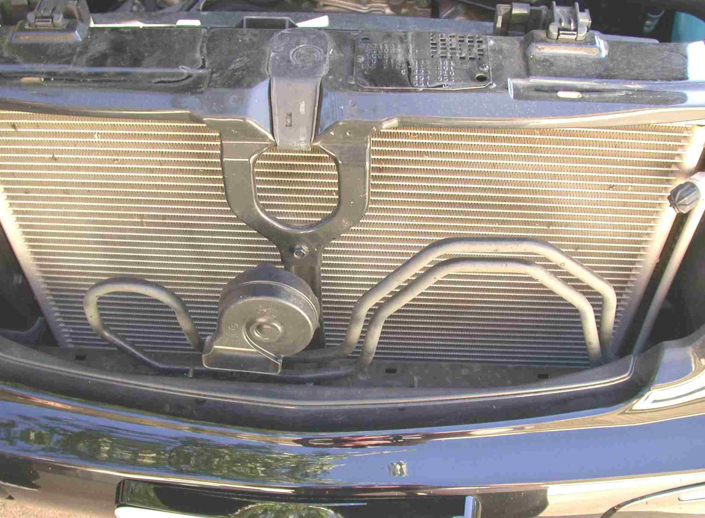

2. Check service information and determine the amount of oil needed to add to the system
when replacing the component. Oil amount = __________ oz.

