Meets ASE Task: (A7-B-10) P-2 Determine procedure to remove and reinstall evaporator; determine required oil type and quantity.

Name:_____________________________________
Date:_____________
Time on Task:_____________
Make/Model/Year:____________________________________
VIN:_________________________________
Evaluation (Enter number from 4, 3, 2, 1) :_________
Evaporator Replacement
Page 216
1. Check service information and determine the specified procedures to follow to replace the evaporator. (list the procedures)
a. _______________ d. _______________ g. _______________
b. _______________ e. _______________ h. _______________
c. _______________ f. _______________ i. _______________
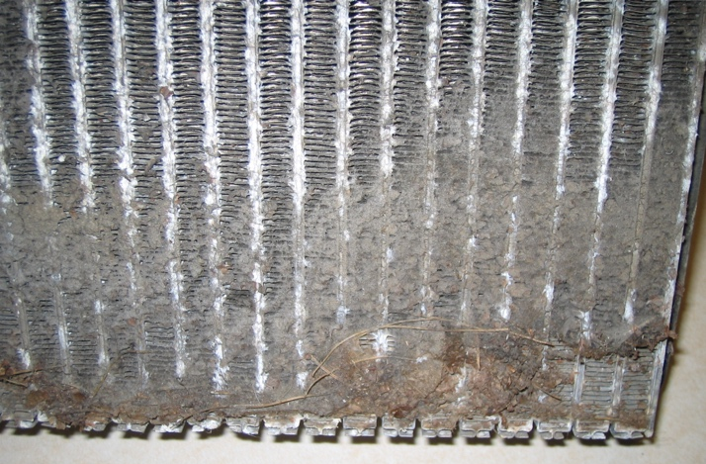

2. Check service information and determine the amount of oil needed to add to the system
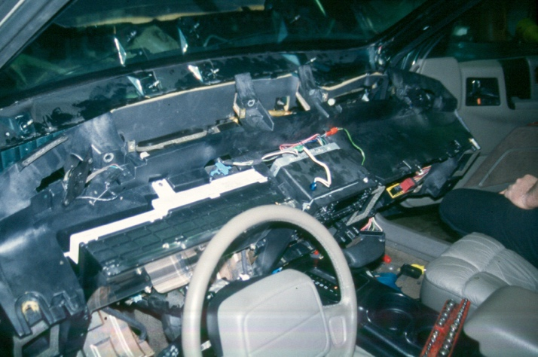
when replacing the component. Oil amount = __________ oz.

