Meets ASE Task: (A7-B-3) P-1 Inspect evaporator housing water drain; perform needed action.

Name:_____________________________________
Date:_____________
Time on Task:_____________
Make/Model/Year:____________________________________
VIN:_________________________________
Evaluation (Enter number from 4, 3, 2, 1) :_________
Evaporator Housing Drain
Page 215
1. Check service information to determine what the customer concern would be if the
evaporator drain was clogged. ____________________________________________
__________________________________________________________________
__________________________________________________________________
2. Check service information and determine the location of the evaporator drain (describe
the location). __________________________________________________________
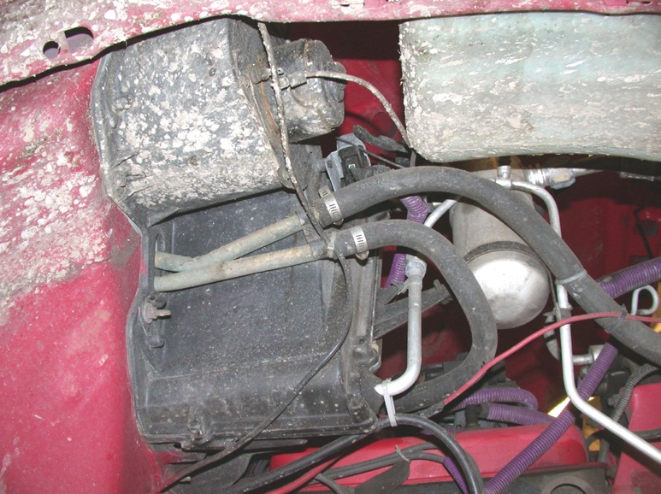
__________________________________________________________________

3. Inspect the drain. Was it clogged? Yes No
4. Based on the inspection, what is the needed action? ____________________________
____________________________________________________________________

