Meets ASE Task: (A7-B-6) P-2 Remove and inspect A/C system mufflers, hoses, lines, fittings, O-rings, seals, and service valves; perform needed action.
Name:_____________________________________
Date:_____________
Time on Task:_____________
Make/Model/Year:____________________________________
VIN:_________________________________
Evaluation (Enter number from 4, 3, 2, 1) :_________
A/C Hoses and Lines
Page 214
1. Check service information for the specified procedure and requirements when
inspecting A/C hoses and lines. Describe the specified procedure. _______________
__________________________________________________________________
__________________________________________________________________

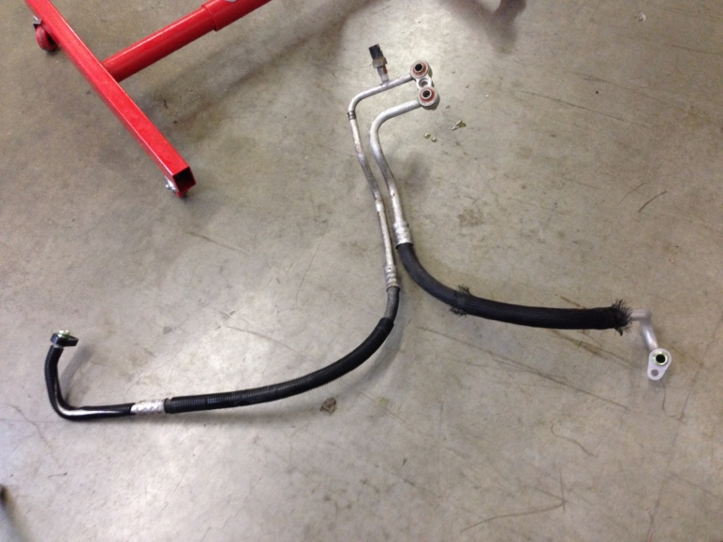
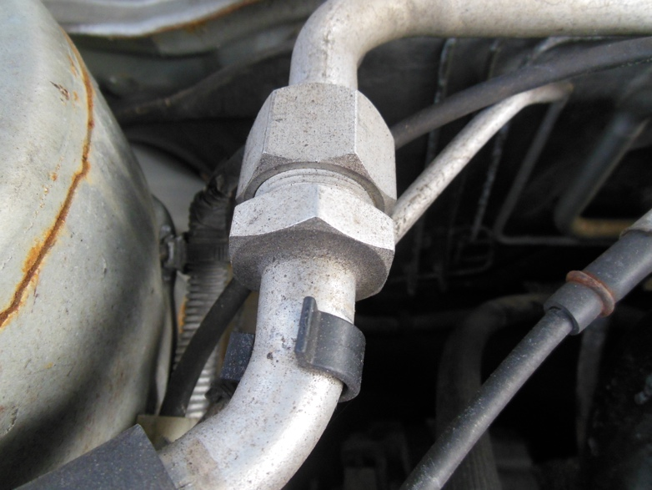

2. Based on the inspection, what is the needed action? ___________________________
_________________________________________________________________
_________________________________________________________________
_________________________________________________________________

