Meets ASE Task: (A7-B-8) P-1 Remove, inspect, and install expansion valve or orifice (expansion) tube.
Name:_____________________________________
Date:_____________
Time on Task:_____________
Make/Model/Year:____________________________________
VIN:_________________________________
Evaluation (Enter number from 4, 3, 2, 1) :_________
Replace Expansion Valve/Orifice Tube
Page 213
1. Check service information for the exact procedures to follow when replacing the
expansion valve or orifice tube. _____________________________________________
____________________________________________________________________
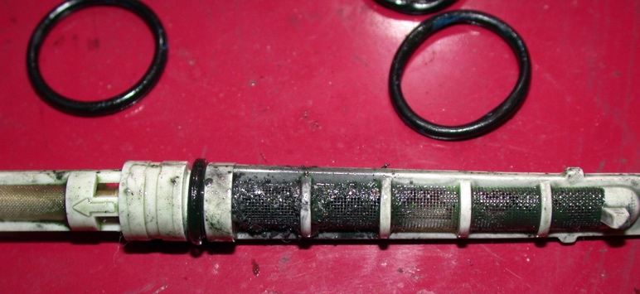
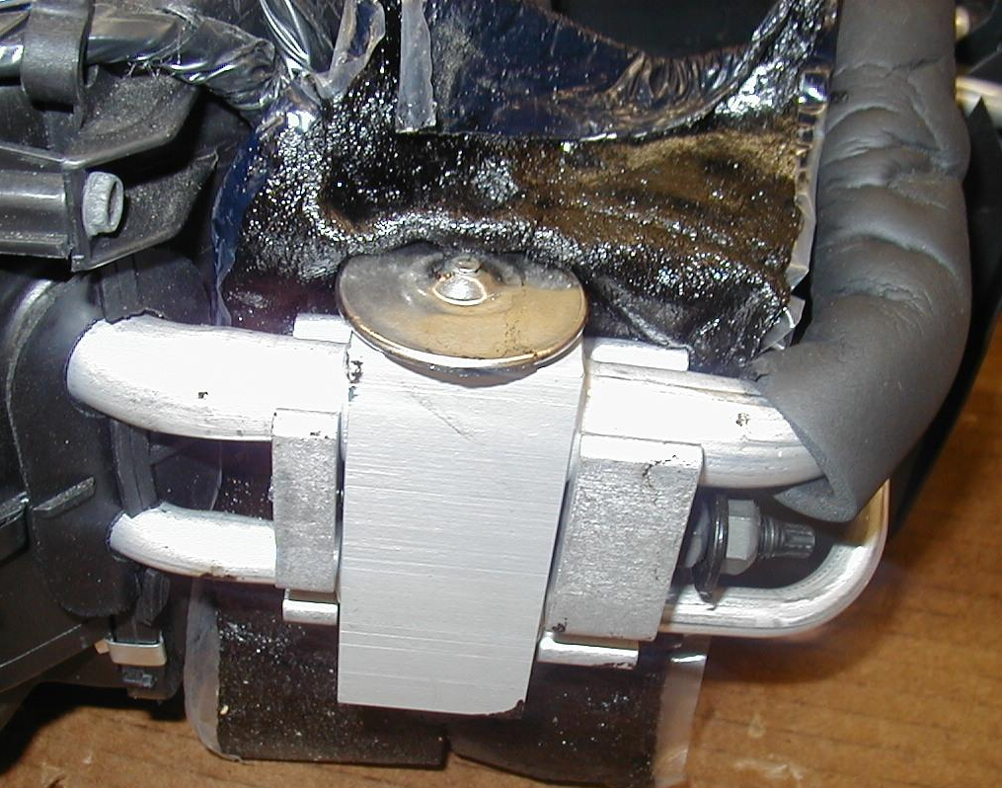
____________________________________________________________________

2. List the tools needed to perform the removal and installation of the expansion valve or
orifice tube.
a. _______________ d. _______________ g. _______________
b. _______________ e. _______________ h. _______________
c. _______________ f. _______________ i. _______________

