Meets ASE Task: (A7-B-7) P-2 Remove, inspect, and replace receiver/drier or accumulator/drier; determine recommended oil type and quantity.
Name:_____________________________________
Date:_____________
Time on Task:_____________
Make/Model/Year:____________________________________
VIN:_________________________________
Evaluation (Enter number from 4, 3, 2, 1) :_________
Receiver/Drier Accumulator Drier
Page 212
1. Check service information for the procedure and tools needed to remove the drier
assembly. ____________________________________________________________
__________________________________________________________________ __________________________________________________________________
__________________________________________________________________
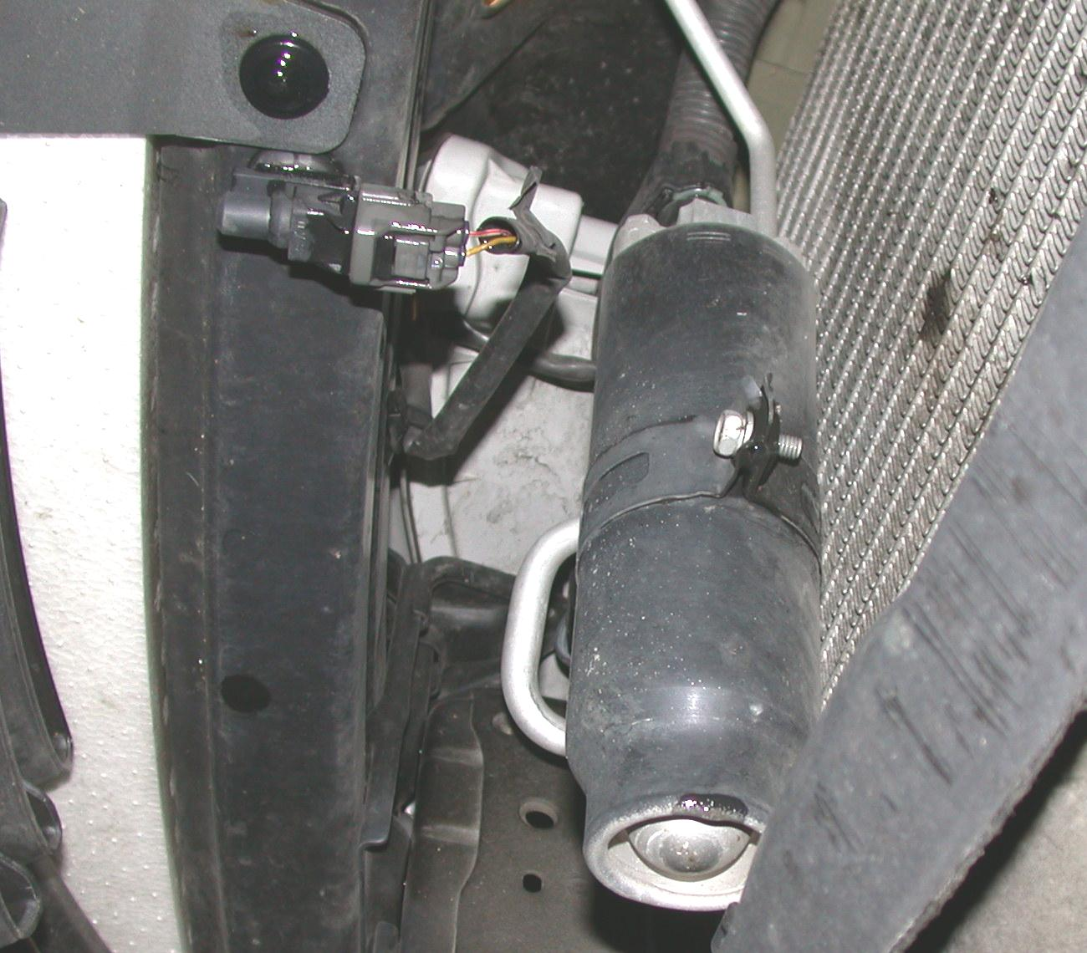

2. Check service information and determine the required amount of oil needed to be
added to the system if the drier assembly is replaced. ___________________ oz.
3. What was the condition of the removed drier assembly? ________________________
__________________________________________________________________
__________________________________________________________________

