Meets ASE Task: (A7-B-2) P-1 Inspect for proper A/C condenser airflow; determine needed action.
Name:_____________________________________
Date:_____________
Time on Task:_____________
Make/Model/Year:____________________________________
VIN:_________________________________
Evaluation (Enter number from 4, 3, 2, 1) :_________
Inspect the Air Conditioning Condenser
Page 211
1. Check service information on how to gain access to the front side of the condenser
(describe what needs to be done). __________________________________________
___________________________________________________________________
___________________________________________________________________
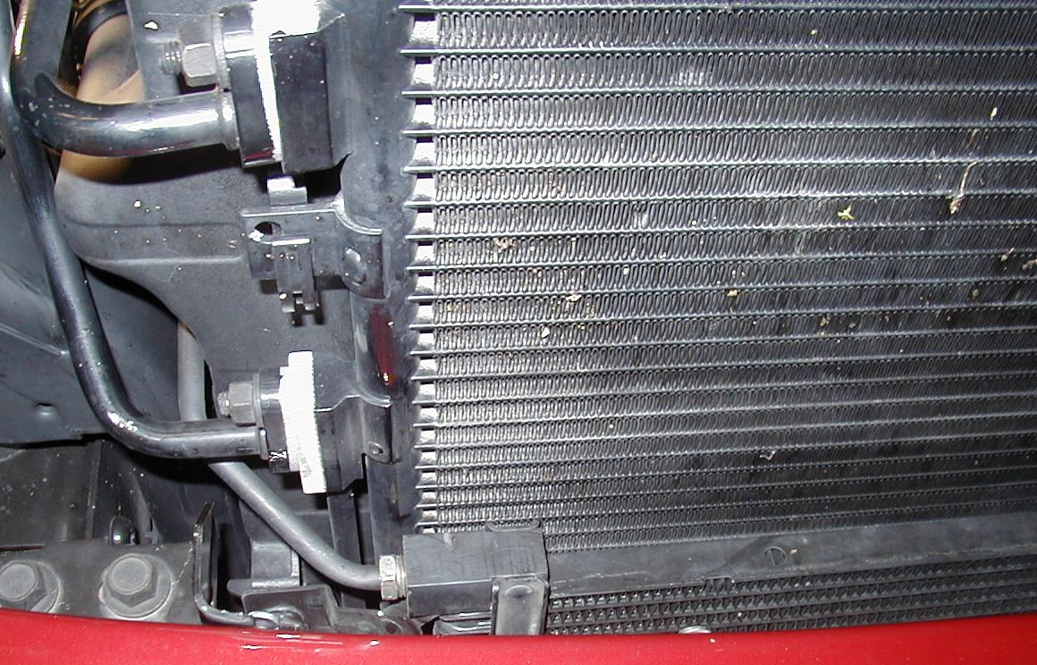

2. What is the recommended method and/or tools needed to clean the condenser?
___________________________________________________________________
___________________________________________________________________
___________________________________________________________________
3. Based on the inspection, what is the needed action? ____________________________
___________________________________________________________________
___________________________________________________________________

