Meets ASE Task: (A7-B-1) P-2 Inspect, test, and/or service A/C compressor clutch components and/or assembly; determine needed action. (A7-B-5) P-1 Remove, inspect, reinstall and/or replace A/C compressor and mountings; determine recommended oil type and quantity.
Name:_____________________________________
Date:_____________
Time on Task:_____________
Make/Model/Year:____________________________________
VIN:_________________________________
Evaluation (Enter number from 4, 3, 2, 1) :_________
Air Conditioning Compressor Service
Page 210
1. Check service information and list the inspection and replacement procedures for
A/C compressor clutch and/or compressor replacement. _________________________________________________________________
_________________________________________________________________
__________________________________________________________________
2. What is the required type and quantity of refrigerant oil? _______________________
__________________________________________________________________
__________________________________________________________________
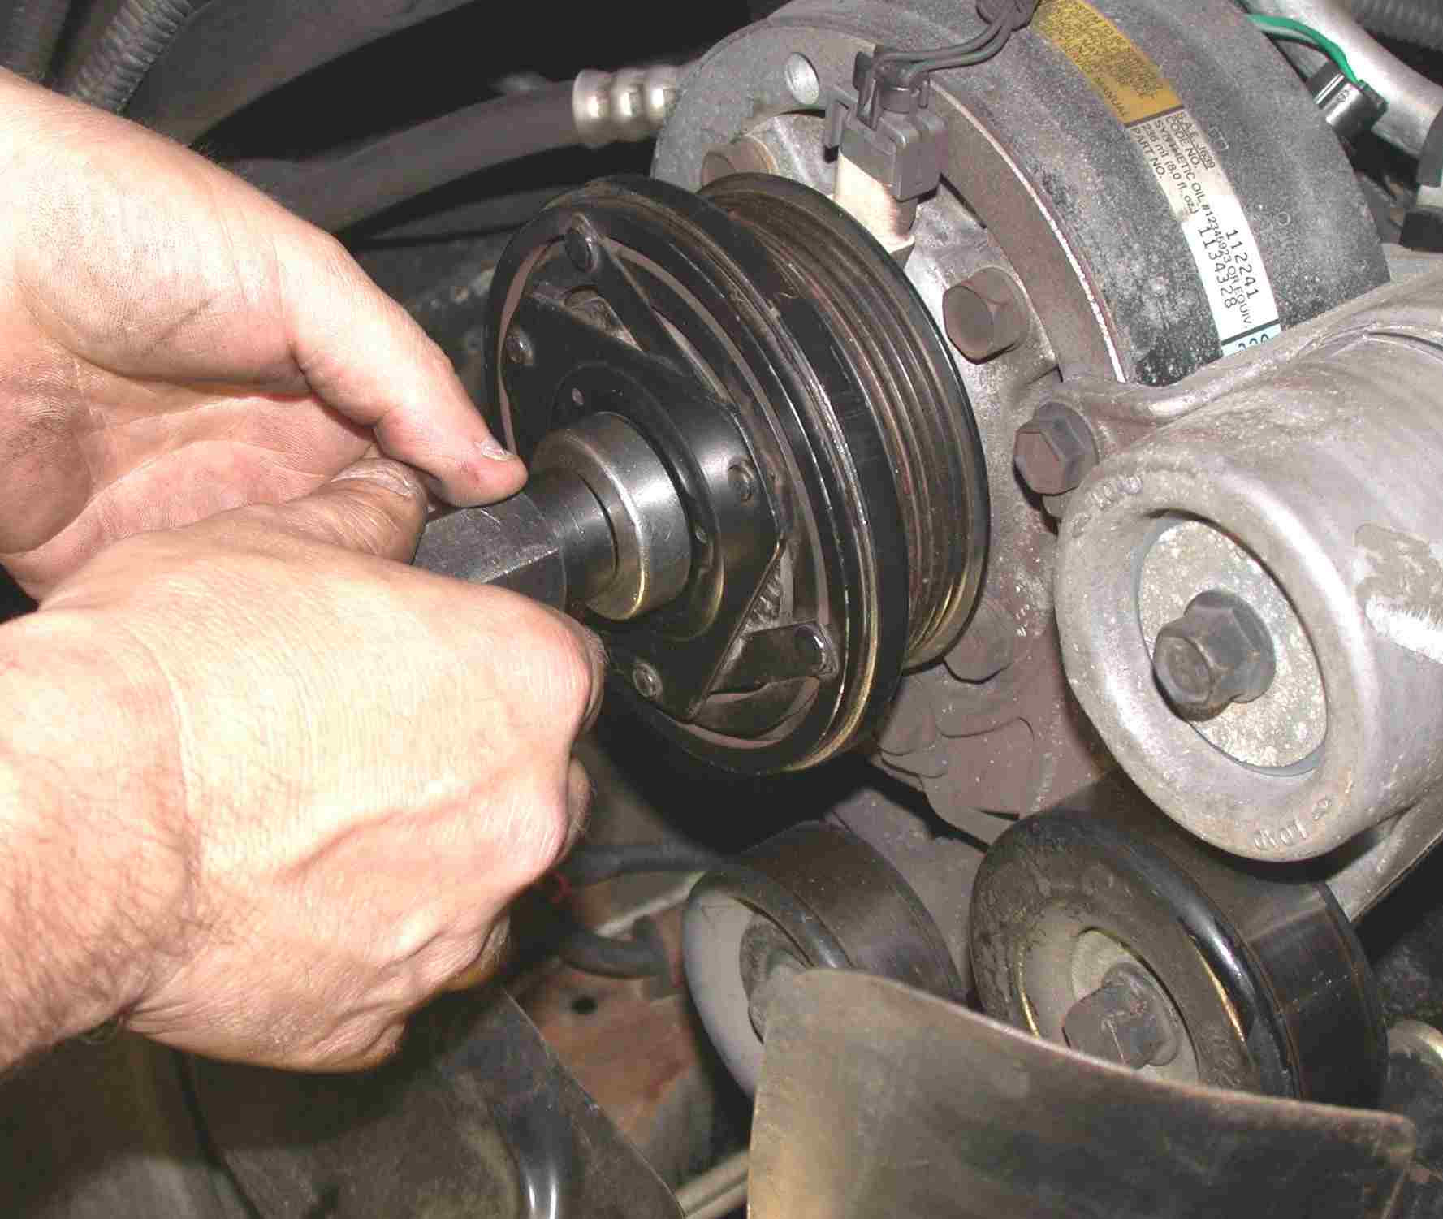

3. Inspect lines and fittings (describe) ________________________________________
4. Based on the inspection, what is the needed action? ___________________________
__________________________________________________________________
__________________________________________________________________

