A telescopic gauge is used with a micrometer to measure the inside diameter of a hole or bore. The inside diameter of a hole can be measured by inserting a telescopic gauge into the bore and rotating the handle lock to allow the arms of the gauge to contact the inside bore of the cylinder. Tighten the handle lock and remove the gauge from the cylinder. Use a micrometer to measure the telescopic gauge. Use a telescopic gauge with a micrometer and measure the following.
Evaluation (Enter number from 4, 3, 2, 1) :_________

Meets ASE task: (A0-B-5) Demonstrate proper use of precision measuring tools (e.g., micrometer, dial-indicator, dial-caliper).
Telescopic Gauge

Name:_____________________________________
Date:_____________
Time on Task:_____________
Make/Model/Year:____________________________________
VIN:_________________________________
Page 21

1. Camshaft bearing bore = _______________________
Specification = ___________
OK NOT OK
2. Main bearing bore (housing bore) measurement = _______________________
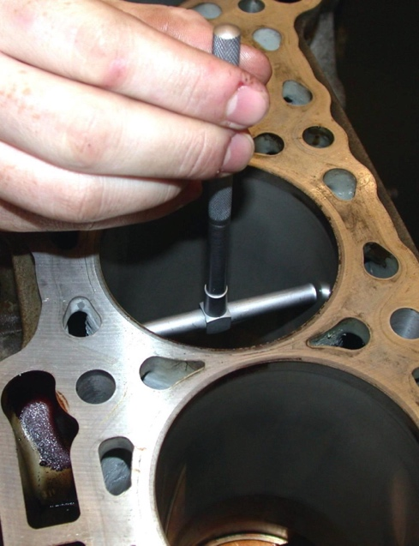
Specification = ___________
OK NOT OK

3. Cylinder bore = ______________
Specification = ___________
OK NOT OK

4. Connecting rod big-end bore
measurement = ________________________
Specification = ___________
OK NOT OK

5. Connecting rod small-end bore measurement = ___________________________
Specification = ___________
OK NOT OK

