Meets ASE Task: (A7-D-4) P-1 Diagnose A/C compressor control systems; determine needed action.

Name:_____________________________________
Date:_____________
Time on Task:_____________
Make/Model/Year:____________________________________
VIN:_________________________________
Evaluation (Enter number from 4, 3, 2, 1) :_________
A/C Compressor Clutch Control Diagnosis
Page 207
1. Check service information and determine the testing and diagnostic procedures to
follow when diagnosing faults in the A/C compressor clutch control circuit (describe
tests).
__________________________________________________________________
__________________________________________________________________
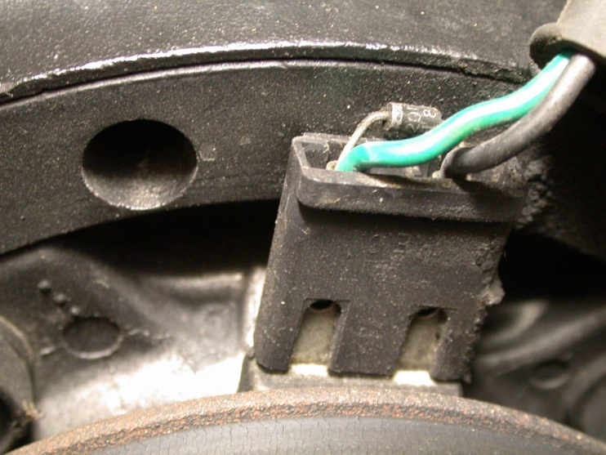

2. What test equipment is specified for use during the diagnosis? Check all that apply.
a. DMM
b. Scope
c. Scan tool
d. Special tester (describe) _____________________________________
e. Other (describe) ___________________________________________
3. After testing the A/C compressor clutch circuit, what is the needed action?
__________________________________________________________________

