**Meets ASE Task:** (A7-C-2) P-2 Inspect and test heater control valve(s); perform needed action.

Name:_____________________________________

Date:_____________

Time on Task:_____________

Make/Model/Year:____________________________________

VIN:_________________________________

Evaluation (Enter number from 4, 3, 2, 1) :_________

**Heater Control Valve**

Page 205

1. Check service information for the specified procedures to follow to test the heater

control valves. ________________________________________________________

__________________________________________________________________

__________________________________________________________________

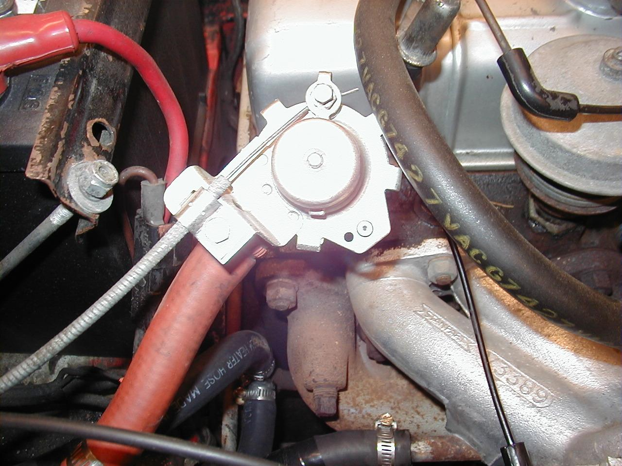

2. Based on the inspection of the heater control valve(s), what is the needed action?

__________________________________________________________________

__________________________________________________________________

__________________________________________________________________

3. Remove and install heater control valve as needed. ________________________

__________________________________________________________________