Meets ASE Task: (A1-D-10) P-1 Inspect and test fan(s), fan clutch (electrical or mechanical), fan shroud, and air dams; determine needed action.
Name:_____________________________________
Date:_____________
Time on Task:_____________
Make/Model/Year:____________________________________
VIN:_________________________________
Evaluation (Enter number from 4, 3, 2, 1) :_________
Cooling Fan and Related Inspections
Page 204
1. Check service information for the specified procedures to follow to test the cooling
fans and fan clutch. ______________________________________________
__________________________________________________________________
__________________________________________________________________
__________________________________________________________________
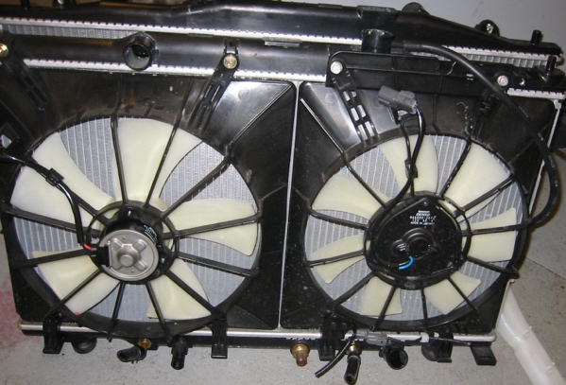
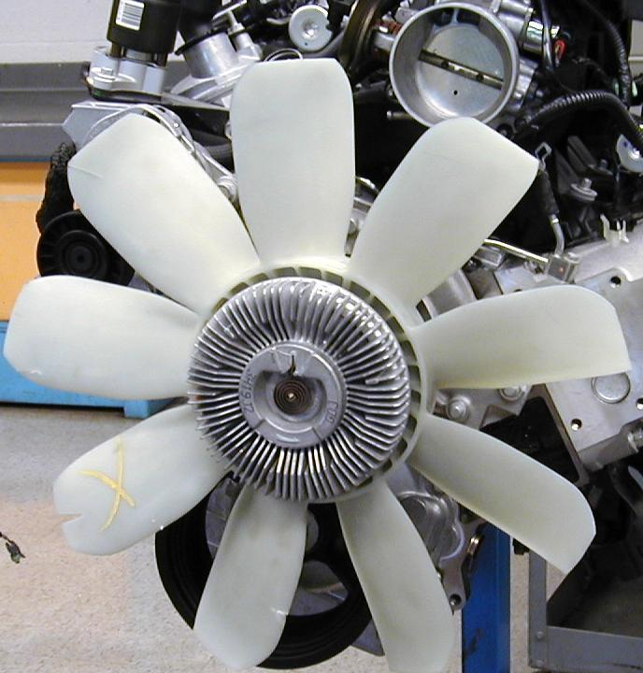

2. The specified current draw (amperes) of the electric cooling fan = _______ amperes.
3. The tested current draw of the cooling fan motor = __________ amperes.
4. Visually check the fan shroud and air dam for damage and note any problems.
__________________________________________________________________
__________________________________________________________________
5. Based on the inspection, what is the needed action? ___________________________
__________________________________________________________________
__________________________________________________________________

