Meets ASE Task: (A1-D-8) P-1 Remove, inspect, and replace thermostat and gasket/seal.
Name:_____________________________________
Date:_____________
Time on Task:_____________
Make/Model/Year:____________________________________
VIN:_________________________________
Evaluation (Enter number from 4, 3, 2, 1) :_________
Thermostat Replacement
Page 203
1. Check service information for the specified procedures to follow to test and replace
the thermostat. ________________________________________________________
__________________________________________________________________
__________________________________________________________________
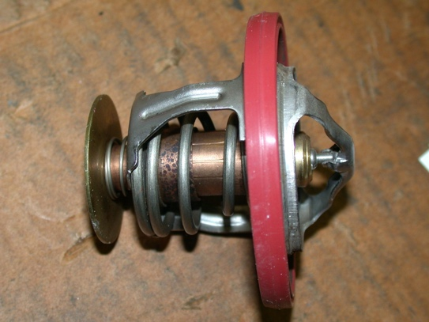
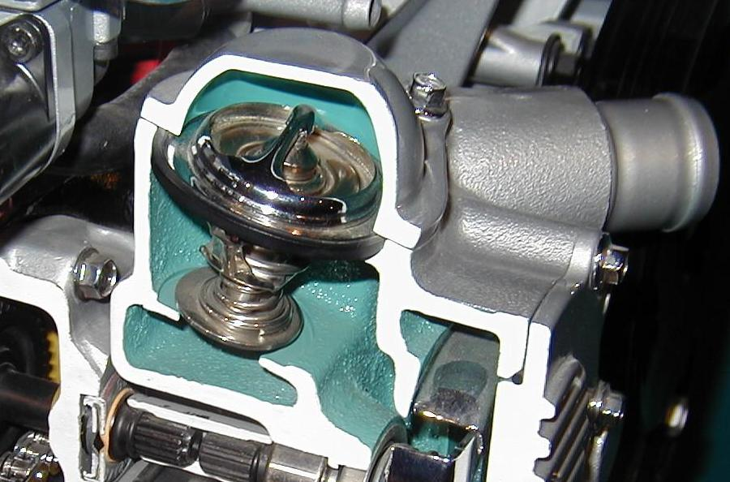

2. Does the replacement thermostat come equipped with a “jiggle” valve? Yes No
If yes, check service information or the instructions from the thermostat
manufacturer as to how the thermostat is to be installed. ____________________
__________________________________________________________________
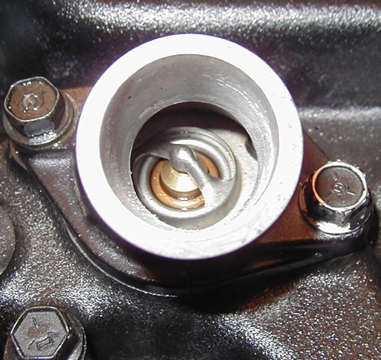
3. What is the specified method to use to be sure that all the air is burped out of the cooling system? ______________________________________
______________________________________
______________________________________

