Meets ASE Task: (A1-D-3) P-1 Perform cooling system pressure and dye tests to identify leaks; check coolant condition and level; inspect and test radiator, pressure cap, coolant recovery tank, heater core, and galley plugs; determine needed action. (A7-C-1) P-1 Inspect engine cooling and heater systems hoses and pipes; determine needed action.
Name:_____________________________________
Date:_____________
Time on Task:_____________
Make/Model/Year:____________________________________
VIN:_________________________________
Evaluation (Enter number from 4, 3, 2, 1) :_________
Cooling System Inspection
Page 202
1. Check the level of coolant in the coolant recovery tank. It should be between the “full
hot” and “full cold” lines.
OK NOT OK

2. After the engine has cooled, remove the radiator cap. The coolant should be at the full level in the radiator.
CAUTION: Do not remove the radiator cap if the engine is hot. The coolant will explosively expand when the cap is removed which can cause severe burns to anyone near the vehicle.
OK NOT OK

3. Check the condition of the radiator hoses.
OK Not OK (describe condition) ____________________________

4. Check the freezing point and boiling point of the coolant.
Freezing point = ___________ [should be -34° F (-36° C) or lower]
Boiling point = ___________
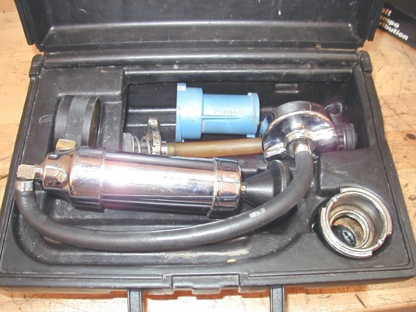
OK NOT OK

5. Pressure test the cooling system by installing a
cooling system pressure tester and pump until
the pressure is equal to the pressure cap value.
Pressure should hold if there are no leaks.
OK NOT OK

6. Test the radiator cap using the cooling system
pressure tester with an adapter that fits the cap.
The cap should hold its rated pressure.
OK NOT OK

7. What is the needed action? _______________________________________________

