Meets ASE Task: (Not specified by ASE)
Name:_____________________________________
Date:_____________
Time on Task:_____________
Make/Model/Year:____________________________________
VIN:_________________________________
Evaluation (Enter number from 4, 3, 2, 1) :_________
Determine Need for Refrigerant Filter
Page 200
1. Check service information and determine when the vehicle manufacturer recommends
the installation of an additional filter in the refrigerant system. __________________
__________________________________________________________________
__________________________________________________________________
2. Check aftermarket information and determine when an additional filter is
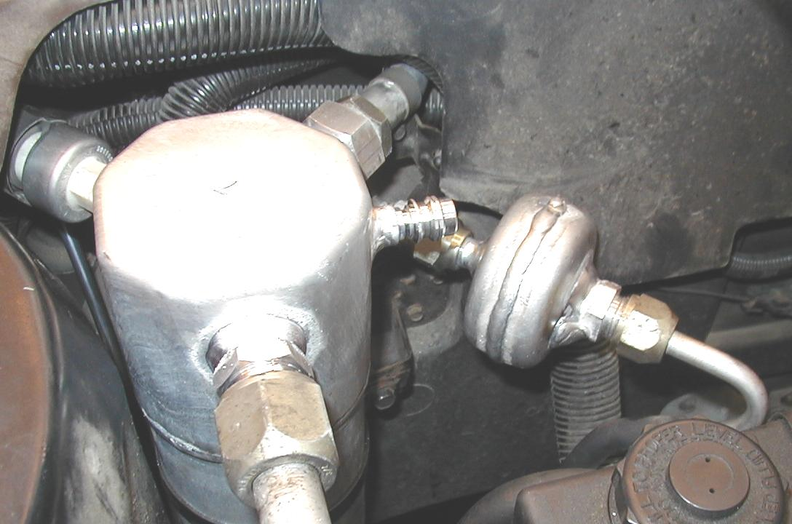
recommended to be installed. _______
____________________________
____________________________
____________________________
____________________________
____________________________
____________________________

3. Where is an additional filter installed? (describe the location) ___________________
__________________________________________________________________
4. Why is the filter installed in this location? ___________________________________
__________________________________________________________________
__________________________________________________________________
5. What was the needed action? _____________________________________________
__________________________________________________________________
__________________________________________________________________

