A dial indicator is a precision measuring instrument used to measure clearance to within thousandths of an inch. Use a dial indicator to measure the following.
Evaluation (Enter number from 4, 3, 2, 1) :_________

Meets ASE task: (A0-B-5) Demonstrate proper use of precision measuring tools (e.g., micrometer, dial-indicator, dial-caliper).
Dial Indicator

Name:_____________________________________
Date:_____________
Time on Task:_____________
Make/Model/Year:____________________________________
VIN:_________________________________
Page 20

1. Crankshaft end play = _____________

Specification = ___________
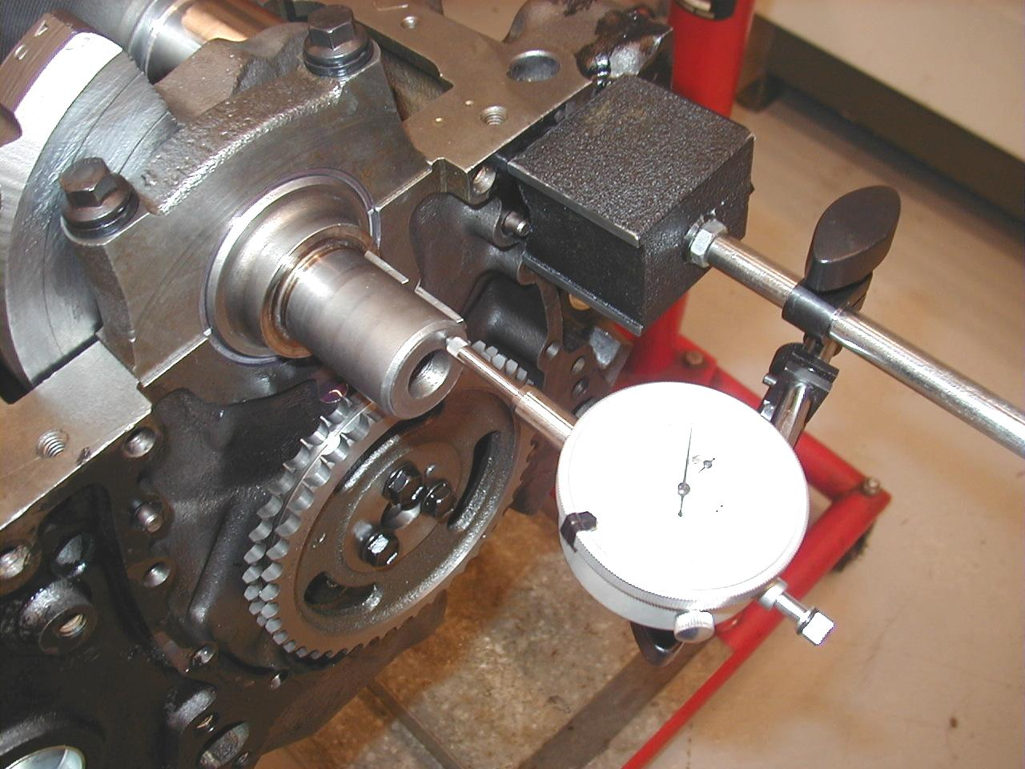
OK NOT OK

2. Crankshaft runout = _____________

Specification = ___________

OK NOT OK

3. Valve guide clearance = __________

Specification = ___________

OK NOT OK

4. Camshaft runout = ______________

Specification = ___________

OK NOT OK

