Meets ASE Task: (A7-A-3) P-1 Retrieve and record DTCs, OBD monitor status, and freeze frame data; clear codes and data when directed.
Name:_____________________________________
Date:_____________
Time on Task:_____________
Make/Model/Year:____________________________________
VIN:_________________________________
Evaluation (Enter number from 4, 3, 2, 1) :_________
HVAC Diagnosis
Page 199
1. Check service information to check how to access data and diagnostic trouble codes.
__________________________________________________________________
__________________________________________________________________
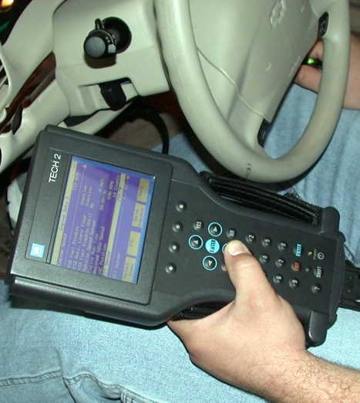

2. What if any diagnostic trouble codes were displayed? _________________________

3. Check service information and determine what protective devices are used on the
vehicle being serviced. Check all that apply.
a. Low-pressure switch (describe location) __________________________
b. High-pressure switch (describe location) __________________________
c. Thermal protective device (describe location) ______________________
d. Other (describe) _____________________________________________
e. Odors? (describe) ___________________________________________
f. Cables and control panel operation ______________________________

