Meets ASE Task: (A7-A-10) P-1 Determine recommended oil and oil capacity for system application.
Name:_____________________________________
Date:_____________
Time on Task:_____________
Make/Model/Year:____________________________________
VIN:_________________________________
Evaluation (Enter number from 4, 3, 2, 1) :_________
Refrigerant Oil
Page 198
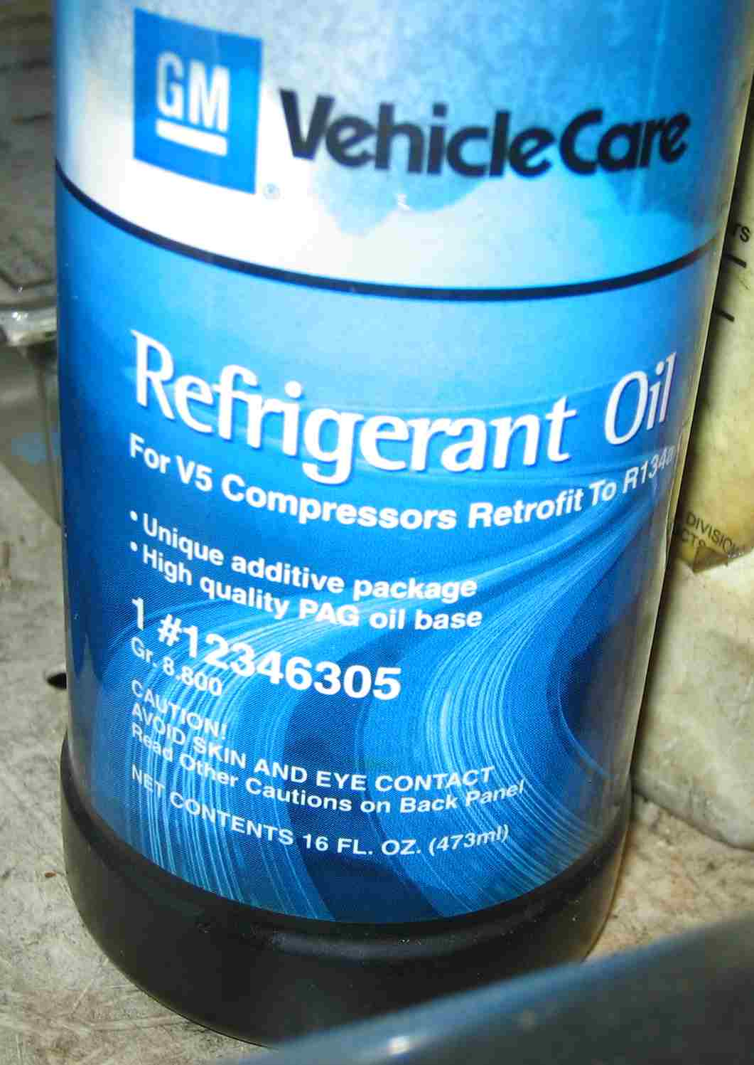
1. Check service information and determine the

recommended oil for the system being

serviced. ____________________________

_________________________________

_________________________________

_________________________________

_________________________________

_________________________________

_________________________________

2. Check service information and determine how much oil should be added for each
replaced component.

Condenser _____________________
Evaporator _____________________
Receiver (accumulator) drier _____________________
Refrigerant lines ______________________
Other (describe) ________________________________________________
3. Inspect oil removed from the system (describe): ______________________________
__________________________________________________________________
__________________________________________________________________
__________________________________________________________________

