Meets ASE Task: (A7-A-6) P-1 Visually inspect A/C system for signs of leaks; leak test A/C system; determine needed action.
Name:_____________________________________
Date:_____________
Time on Task:_____________
Make/Model/Year:____________________________________
VIN:_________________________________
Evaluation (Enter number from 4, 3, 2, 1) :_________
Leak Test the Air Conditioning System
Page 197
1. Check service information and describe the leak detection recommended by the

vehicle manufacturer. _________________________________________________________________

__________________________________________________________________

2. What type(s) of leak detection tools or equipment was used (describe)? ___________

__________________________________________________________________
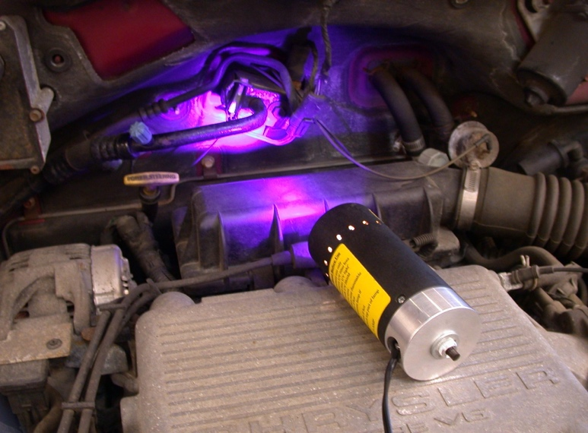

3. Was a leak detected? Yes No If yes, describe the location: __________

__________________________________________________________________

4. Based on the test results, what is the needed action? __________________________

_________________________________________________________________

