Meets ASE Task: (A7-D-8) P-2 Check operation of automatic HVAC system; determine needed action.

Name:_____________________________________
Date:_____________
Time on Task:_____________
Make/Model/Year:____________________________________
VIN:_________________________________
Evaluation (Enter number from 4, 3, 2, 1) :_________
Automatic AC System Operation
Page 192
1. Check service information for the specified procedures to follow to inspect and test
the A/C system operation. Describe the procedures. ___________________________
__________________________________________________________________
__________________________________________________________________

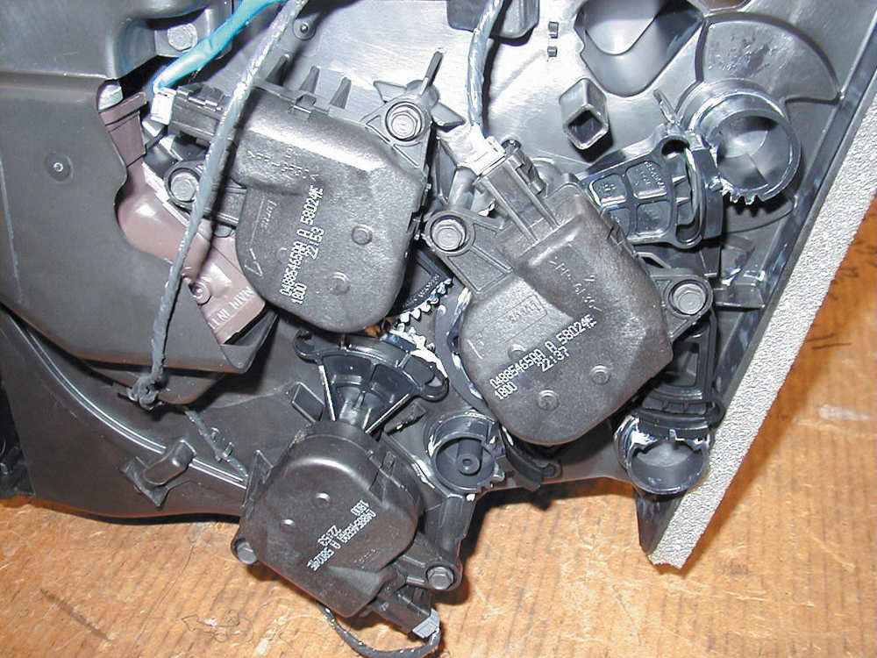
2. What test equipment was specified to test the A/C system operation? Check all that
apply.
a. DMM
b. Scan tool
c. Special tester (describe) ______________________________________ d. Other (describe) ____________________________________________
3. Based on the test results, what is the needed action? ___________________________
_____________________________________________________________________

