Meets ASE Task: (A7-D-5) P-2 Diagnose malfunctions in the vacuum, mechanical, and/or electrical components and controls of the HVAC system; determine needed action.

Name:_____________________________________
Date:_____________
Time on Task:_____________
Make/Model/Year:____________________________________
VIN:_________________________________
Evaluation (Enter number from 4, 3, 2, 1) :_________
HVAC Electrical Controls
Page 191
1. Check service information and describe the specified procedures to follow to diagnose
HVAC electrical control faults. __________________________________________
____________________________________________________________________
____________________________________________________________________
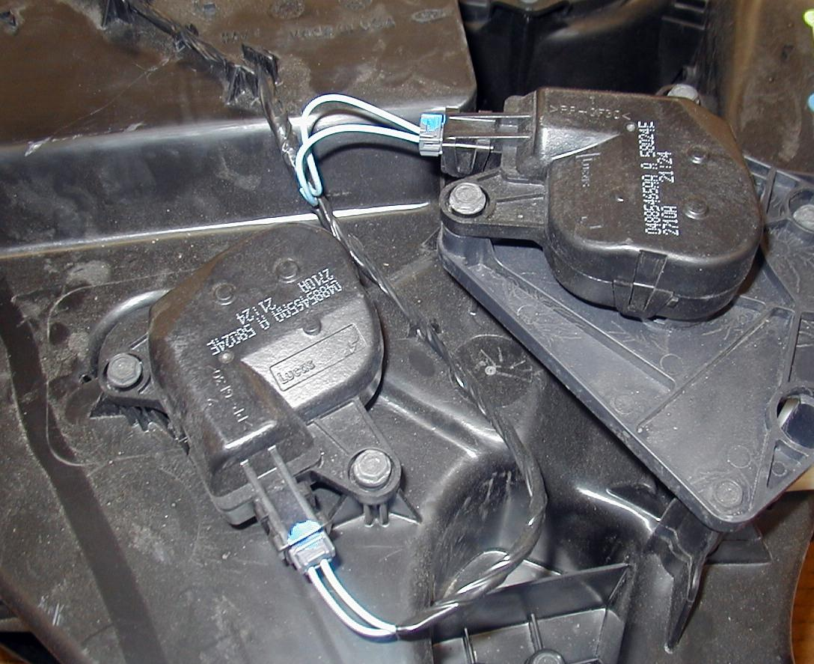

2. Check all the test equipment specified that is needed to diagnose HVAC electrical
control faults.
a. DMM
b. Scan tool
c. Special tester (describe) ____________________________________
d. Other (describe) __________________________________________
3. After diagnosis following the specified procedures, what is the needed action?
_______________________________________________________________
_______________________________________________________________

