A straight edge is a precision ground metal measuring gauge that is used to check the flatness of engine components when used with a feeler gauge. Use a straight edge to check the flatness of the following.

Evaluation (Enter number from 4, 3, 2, 1) :_________

Meets ASE task: **(**A0-B-5) Demonstrate proper use of precision measuring tools (e.g., micrometer, dial-indicator, dial-caliper).

**Straight-Edge**

Name:_____________________________________

Date:_____________

Time on Task:_____________

Make/Model/Year:____________________________________

VIN:_________________________________

Page 19

**1.** Cylinder heads ________________________________________________________

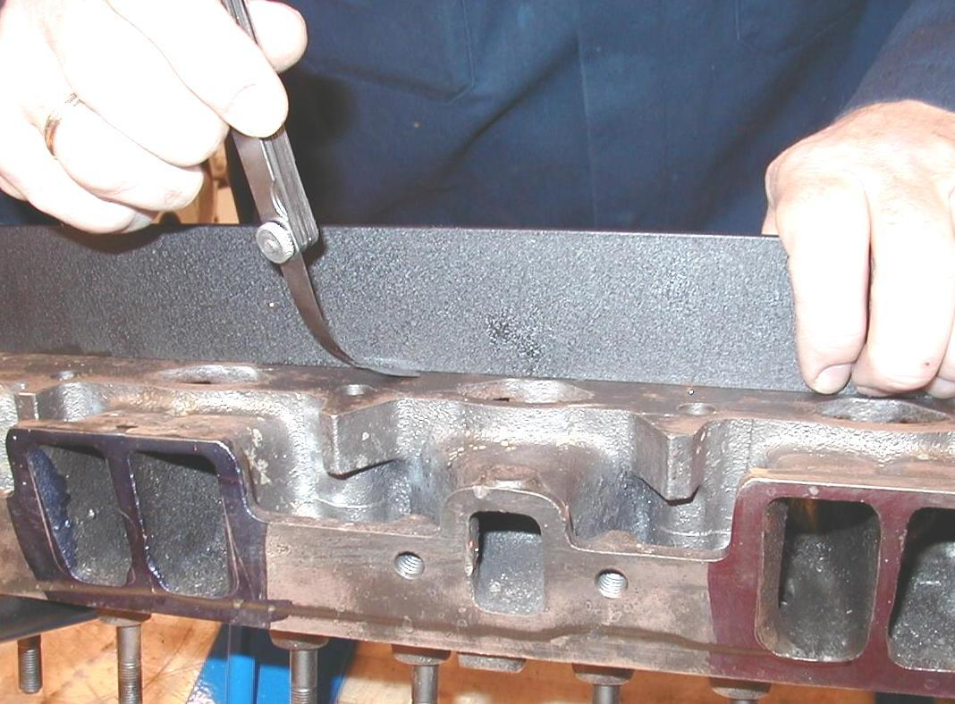 Specification = ___________

**OK  NOT OK**

**2.** Cylinder block deck ____________________________________________

Specification = ___________

**OK  NOT OK**

**3.** Straightness of the main bearing bores (saddles) ______________________________

Specification = ___________

**OK  NOT OK**